 *Final mark awarded*

FACULTY OF COMPUTING, ENGINEERING and SCIENCE

Assessment Cover Sheet and Feedback Form 2017/18

|  |  |  |  |  |
| --- | --- | --- | --- | --- |
| **Module Code:**  NG4D900 | **Module Title:**  MEng Major Group Project | | **Lecturer:**  Guoping Liu | |
| **Assignment No:**  1 | **No. of pages in total including this page:** | | **Maximum Word Count:** 15000 | |
| **Assignment Title: Report Tasks:** | | | | |
| **Date Set:**  27/09/2017 | | **Submission Date:**  25/04/2018 | | **Feedback Date:**  09/05/2018 |

|  |
| --- |
| **Section A: Record of Submission** |
| **Record of Submission and Plagiarism Declaration**  I declare that this assignment is my own work and that the sources of information and material I have used (including the internet) have been fully identified and properly  acknowledged as required in the referencing guidelines provided.  **Fit to Sit Policy**  The University operates a fit to sit policy whereby you, in submitting or presenting yourself for any assessments, are declaring that you are fit to sit the assessment. You cannot subsequently claim that your performance in that assessment was affected by extenuating circumstances.  **Student Number:**  You are required to acknowledge that you have read the above statements by writing your student number(s) above.  (If this is a group assignment, please provide the student numbers of **ALL** group members)  **Details of Submission**   * IT IS YOUR RESPONSIBILITY TO KEEP A RECORD OF ALL WORK SUBMITTED. * Work should be submitted as detailed in your student handbook. You are responsible for checking the method of submission. * **Late Submission** – Work must be submitted by the submission date. If you fail to do this, you will be allowed a further five working days to submit the work but the work will be awarded a maximum mark of 40%. If you fail to submit work within five working days of the submission date, you will be deemed to have failed this assessment which will be given a mark of 0%. However see extenuating circumstances below.   **Extenuating Circumstances:** if there are any exceptional circumstances that may have affected your ability to undertake or submit this assignment, make sure you contact your Advice Shop and also see either<http://cesstudents.southwales.ac.uk/Ext_circs/>(Trefforest) or <http://glyntaffcampus.southwales.ac.uk/advice_shop/Extenuating_Circumstances/>(Glyntaff) |

|  |  |
| --- | --- |
| **Section B : Marking and Assessment** | |
| This assignment will be marked out of 100%  This assignment contributes to 100% of the total module marks. This assignment is bonded / non- bonded. Details : | It is estimated that you should spend approximately  20 hours on this assignment. |

|  |  |  |
| --- | --- | --- |
| **Learning Outcomes** |  | |
| **This assignment addresses the following learning outcome(s) of the module:**   1. Work effectively as part of a multi-disciplinary team in developing and implementing a solution to a complex, industrially relevant, major technical problem, communicating effectively with a team members and, if appropriate, personnel from the sponsoring industry. 2. Demonstrate a critical and conceptual understanding of all aspects of the work, and contribute to both the production of a detailed technical report, and a concise technical presentation. 3. Demonstrate a critical and conceptual understanding of all aspects of the work, and contribute to both the production of a detailed technical report, and a concise technical presentation. | | |
| **Marking Scheme** | **Marks**  **Available** | **Marks**  **Awarded** |
| **1.** See page 5 |  |  |
| **2.** |  |  |
| **3.** |  |  |
| etc. |  |  |
|  |  |  |

|  |  |
| --- | --- |
| **Assessment Criteria** | |
| **Performance Level** | **Criteria** |
| Fail (<40%) |  |
| 3rd Class / PASS (40%-49%) |  |
| Lower 2nd Class / PASS (50%-59%) |  |
| Upper 2nd Class / MERIT (60%-69%) |  |
| 1st Class / DISTINCTION (70% +) |  |

|  |  |  |  |
| --- | --- | --- | --- |
| **Section C : Marker’s Feedback** | | | |
| **Lecturer’s Comments:** | | | |
| ……………………………………………………………………………………………………………… | | | |
| ……………………………………………………………………………………………………………… | | | |
| ……………………………………………………………………………………………………………… | | | |
| ……………………………………………………………………………………………………………… | | | |
| ……………………………………………………………………………………………………………… | | | |
| ……………………………………………………………………………………………………………… | | | |
| ……………………………………………………………………………………………………………… | | | |
| ……………………………………………………………………………………………………………… | | | |
| ……………………………………………………………………………………………………………… | | | |
| ……………………………………………………………………………………………………………… | | | |
| ……………………………………………………………………………………………………………… | | | |
| ……………………………………………………………………………………………………………… | | | |
| ……………………………………………………………………………………………………………… | | | |
| **Areas to concentrate on next time:** | | | |
| Report structure | Research | Content | Team work |
| Referencing | Presentation |  |  |
| **Lecturer’s signature:** | | **Date:** | **Mark awarded:** |
| **All marks are subject to confirmation by the Assessment Boards** | | | |

|  |  |  |
| --- | --- | --- |
| **Task distribution per student** | | |
| **Student ID** | **Name** | **Section/sub-section** |
| **13013521** | **Thomas Brown** |  |
| **15021106** | **Kayin Templar** |  |
| **14031329** | **Miguel Santos** |  |

Table of contents

1. Introduction 4

1.1. Overview 4

1.2. Project goals 4

1.3. The competition 4

1.3.1. Regulations 4

1.3.2. The race track 5

1.3.3. Results from 2017/18 8

2. Features 9

3. Design 10

3.1. Mechanical 10

3.2. Electrical 11

3.2.1. Provided Designs 11

3.2.2. Sensor Bar 11

3.2.3. Power Board 13

3.3. Speed Control and Feedback 16

3.3.1. Hall Effect Sensor 17

3.3.2. Accelerometer 19

3.4. Overall Electronic Design 20

3.5. Control theory 21

3.6. Software 21

3.6.1. Program structure 21

3.6.2. Backend 21

3.6.3. Frontend 23

4. Implementation 24

4.1. Mechanical 24

4.2. Electrical 25

4.2.1. Provided Circuits 25

4.2.1. Hall Effect circuits 26

4.2.1. Peripheral Board 26

4.3. Software 27

4.3.1. Backend 27

4.3.1.1. RTOS 27

4.3.1.2. Peripheral drivers 27

4.3.1.3. Communication protocol 27

4.3.2. Frontend 27

4.3.2.1. User application – car controller 27

4.3.2.2. User interactivity – command shell and Android App 27

4.3.3. Extra features 28

4.3.3.1. MIDI Player 28

4.3.3.2. Wireless firmware deployment (bootloader) 28

4.3.3.3. Backward and forward compatibility 28

5. Testing 29

5.1. Mechanical 29

5.2. Electrical 29

5.2.1. Sensor board 29

5.2.2. Power board 30

5.2.3. Hall Effect Sensors 31

5.3. Software 32

6. Performance 33

7. Problems and solutions 34

8. Next year proposals 35

9. Discussions 36

10. Conclusion 37

11. References 38

Appendices 1

Appendix A: 1

Appendix B: 2

Appendix C: 3

List of tables

Table 3‑1 - Software: the backend structure 22

Table 3‑2 - Software: the frontend structure 23

List of figures

Figure 1‑1 - Track piece: Right angle curve 5

Figure 1‑2 - Track piece: T600 5

Figure 1‑3 - Track piece: T300 5

Figure 1‑4 - Track piece: T250 6

Figure 1‑5 - Track piece: T150 6

Figure 1‑6 - Track piece: R600 6

Figure 1‑7 - Track piece: R450 6

Figure 1‑8 - Track piece: Right lane change 7

Figure 1‑9 - Track piece: Left lane change 7

Figure 1‑10 - Track piece: Slope 7

Figure 3‑1 - Credit www.electronics-tutorials.ws 17

List of abbreviations

|  |  |
| --- | --- |
| m | Metre |
| mm | Millimetre |
| g | Gram |
| s | Second |
| PID | Proportional – Integral – Derivative |
| RTOS | Real Time Operating System |
| MIDI | Musical Instrument Digital Interface |
| TCP | Transmission Control Protocol |
| IP | Internet Protocol |
| UART | Universal Asynchronous Receiver-Transmitter |
| IR | Infrared |
| MCU | Microcontroller Unit |
| LED | Light Emitting Diode |
| DC | Direct Current |
| PWM | Pulse Width Modulation |
| FET | Field Effect Transistor |
| IC | Integrated Circuit |
| I/O | Input / Output |
| GPIO | General Purpose Input / Output |
| IDE | Integrated Development Environment |
| API | Application Programming Interface |

# Introduction

## Overview

Every year the University of South Wales participates in an organised competition for students all across Europe by Renesas through partnership with the university.

In this competition, each team is tasked to build a racing car controlled with a microcontroller made from either an official kit provided by Renesas, or a custom built car. The winning team receives a certain prize, including the teams in second and third place.

This report will cover the progress of the work from the perspective of a regular academic group project, as well as a project with the competition as the end goal.

## Project goals

From the academic standpoint, this project is an attempt and execution of developing a car that is:

1. Better than last year’s (2016/2017), in terms of software and most importantly hardware;
2. Smarter in regards to its program algorithm through the use of “pseudo” machine learning

In addition to building a new car, another project goal was to actually improve last year’s code on the same old hardware. This was to allow the development of the software before the kit’s hardware could arrive. This way, it would be possible to just upload the code into the new car once it was built.

## The competition

### Regulations

There are many competition regulations that must be followed in order to prevent team disqualification. The main regulations that are not straightforward/obvious are:

1. The autonomous car must be controlled using a Renesas microcontroller, specifically the RX62G/RX62T;
2. Adhesive materials are not allowed to be used on the wheels – would provide grip, thus why some students would prefer it;
3. The maximum dimensions of the car are 300 mm wide and 150 mm tall;
4. Any material being used in the car’s hardware that might affect and/or destroy the track is strictly prohibited;
5. All cars must be subjected to inspection prior to the race. If the car does not pass this test the team is immediately disqualified even before they get the chance to race;
6. After inspection, the team must not alter in any way the shape or form of the car, including the batteries and tyres. Software modification is excluded from this rule;
7. Adding “hard-coded” data regarding the track’s specifications into the microcontroller’s memory prior to the competition IS allowed;
8. Starting the race before the signal results in disqualification;
9. Obstruction of other machines will also lead to complete disqualification of the team.

### The race track

The track is composed of lustreless acrylic pieces that are 300 mm wide and 30 mm thick. Each piece is supported by plywood which provides 27mm of extra height. In addition, each track component fits with the next which might have a different length, in fact, there are 10 types of track pieces, as shown below (all dimensions are in mm - millimetres):

* **Track type 1 – Right angle curve**

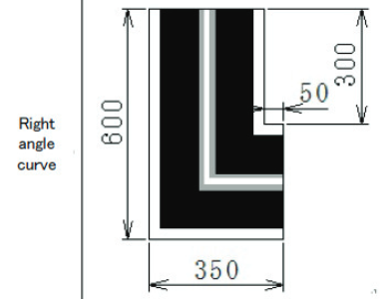

Figure 1‑1 - Track piece: Right angle curve

* **Track type 2 – T600**

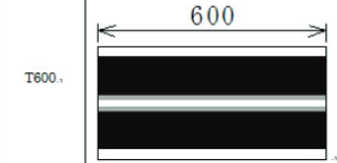

Figure 1‑2 - Track piece: T600

* **Track type 3 – T300**

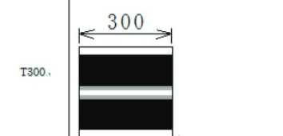

Figure 1‑3 - Track piece: T300

* **Track type 4 – T250**

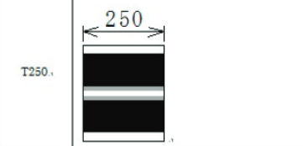

Figure 1‑4 - Track piece: T250

* **Track type 5 – T150**

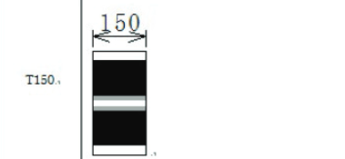

Figure 1‑5 - Track piece: T150

* **Track type 6 – R600**

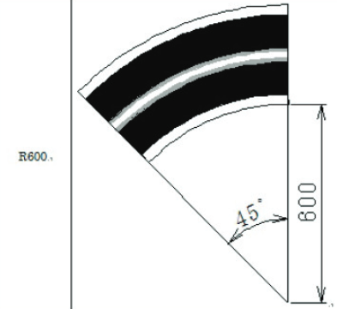

Figure 1‑6 - Track piece: R600

* **Track type 7 – R450**

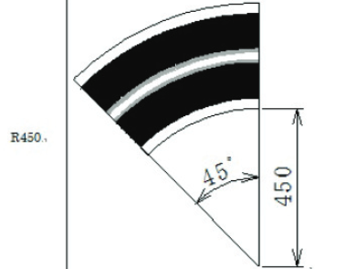

Figure 1‑7 - Track piece: R450

* **Track type 8 – Right lane change**

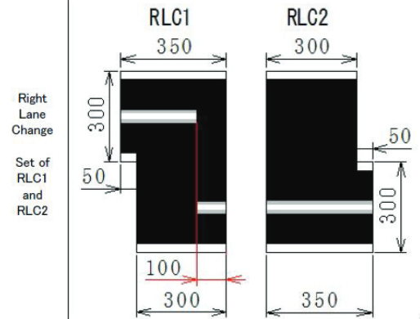

Figure 1‑8 - Track piece: Right lane change

* **Track type 9 – Left lane change**

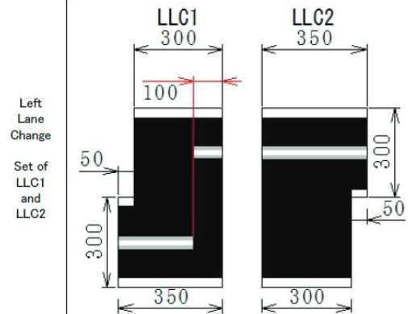

Figure 1‑9 - Track piece: Left lane change

* **Track type 10 – Slope**

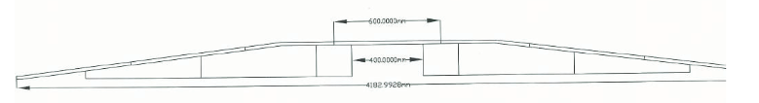

Figure 1‑10 - Track piece: Slope

It was fortunate to have a copy of these track pieces manufactured last year. The development process wouldn’t have gone as far as it did if there was no track to test the car on. Besides, having an improvised track might negatively impact the end result since the real track is completely different in terms of its specifications in comparison with the improvised version.

### Results from 2017/18

Despite all of the promises and potentials for this project, it was extremely unfortunate for the USW team in this year of 2017/18 to have entirely missed the competition. This was due to complications in the transportation (flight between countries Netherlands (Amsterdam) – Germany (Nuremberg)). Thankfully, a USW professor managed to make the recordings of the competition which allowed us to benchmark the winner’s performance against our test data.

(The results were also published after the competition, however, the short demonstration videos provided by Renesas do not favour our intent of measuring an approximated value of the velocity and acceleration of the winner’s car.)

The results were (in order):

1. Romania
   1. University: Gheorge Asachi Technical University os Iasi
   2. Penalties: 0
   3. Time: 01 minutes 35.25 seconds
2. Romania
   1. University: University of Craiova
   2. Penalties: 0
   3. Time: 01 minutes 55.3 seconds
3. Germany
   1. University: Harz University
   2. Penalties: 0
   3. Time: 02 minutes 01 seconds

# Features

Several features were implemented in the car in order to reach the goals of the project. In order to achieve the first goal – build a better car from the hardware and software perspective the features were implemented:

1. **Mechanical**
   1. Lower the height of the car to provide stability;
   2. Redistribute the centre of gravity by laying the batteries flat at the back of the car and by using only one structural deck for accommodating the electronics instead of one;
   3. Increase the length of the sensor bar to allow the car to detect the line at a greater distance.
2. **Electrical**
   1. In addition to the speed sensor (Hall-Effect sensor), use an accelerometer to provide additional data regarding the motion of the car, specifically the momentum vector.
3. **Software**
   1. Use RTOS in order to have accurate control of the tasks being run in the program;
   2. Properly implement PID controller with Integral coefficient and Integral Windup.

The two last project goals – improved/smarter hardware and software, were achieved through the implementation of the features:

1. **Electrical**
   1. Designed small board which accommodates a resistor network for measuring the voltage of the batteries, the accelerometer and a Bluetooth module (HC06) in order to communicate wirelessly with the car in real time;
   2. Hall Effect speed sensor (as opposed to an IR Encoder speed sensor);
2. **Software**
   1. Full-duplex communication through UART;
   2. Layered communication protocol that uses UART as the Data Link layer. Robustness and transparency (seamless) were also features designed into this protocol;
   3. Interactive real-time communication through a command line prompt and/or Android application;
   4. Intelligent and dynamic car control algorithms. These modes allow the car to use a set of different rules during the race. In short, the modes are: Basic, Advanced and Smart.

These features will be discussed in detail in the following report sections **3. Design** and **4. Implementation**.

# Design

## Mechanical

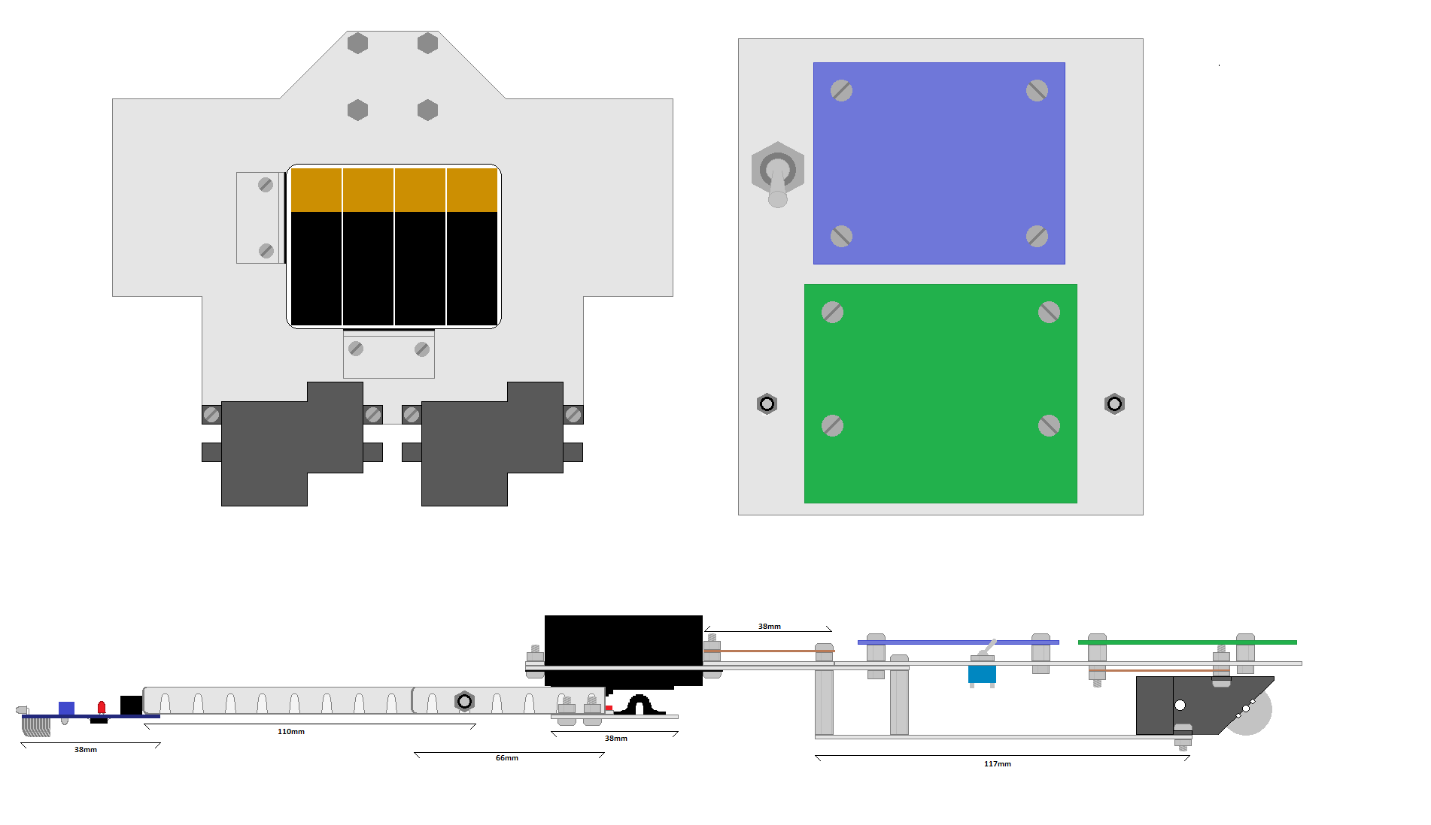In order to maximise the performance of the car, the mechanical design must be changed to give this car an edge over the default design. A problem that other cars have is a high centre of mass, which means that they have to take corners at a slower speed to avoid going out. Below is the mechanical design of this car. There are no wheels shown in this design to make it easier to see everything.

This design has the MCU board and Power board on the same level (top right), as opposed to the provided design that has them on two separate levels. This requires extending the length of the car by 30mm but allows the car to be much less tall. This top-level plate is supported by the front pillars and the gearboxes. Having the power board on the top level should help to sort out some of the cooling issues present in other cars.

The servo board is attached to two arms extending from the front axle much like the original design, but in this design the middle of the arms are secured by nylocs, which allow free movement of the arm without it becoming loose.

The top left of this diagram shows the bottom level. The battery pack (containing eight AA batteries) is supported by two small plates with Velcro strips. This should sufficiently stop it becoming loose while the car moves, while still making it easy to remove the battery pack for charging

The switch has been repositioned from the area behind the servo to make room for the peripheral Veroboard. The makes all circuits easily accessible except for the Hall Effect circuits, which have to be positioned above the gearboxes.

The gearboxes are both positioned with half of the box hanging off the back of the car. This helps two-fold; to reduce the size of the bottom level, and allowing more air to reach the motors to cool them.

## Electrical

### Provided Designs

Three boards are included in the initial project package, the IR LED sensor bar, the Power board, and the MCU board. The MCU board arrives soldered however the others must be soldered. This section will explain the function of these boards, as they must be understood in case they develop a fault, and for the designing of added peripherals.

### Sensor Bar

The first of the provided circuit designs to be discussed here is the sensor bar. The purpose of this circuit is to detect the white line on the track, and send this data to the MCU board so that the car can be controlled.

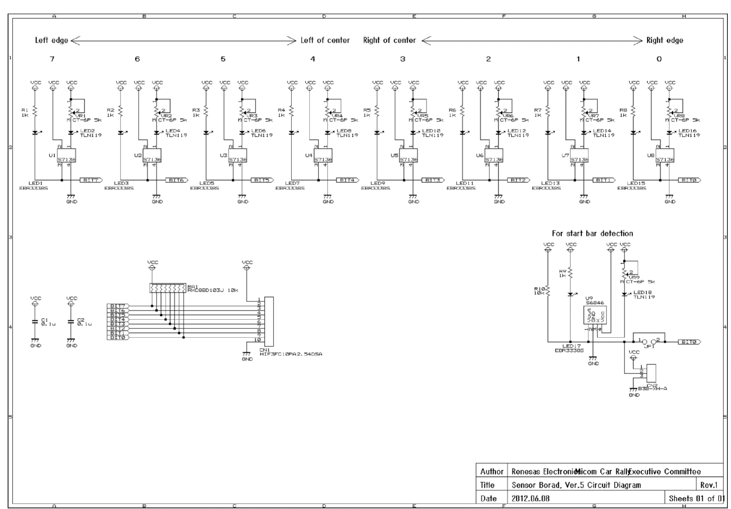

Above is the schematic for the sensor bar. As each of the LED-IR sensor sections are identical, one of them can be looked at as an example.

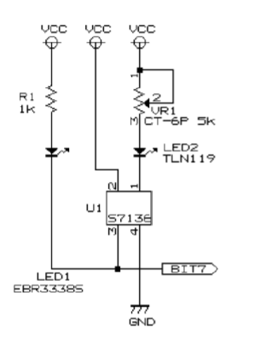The left most LED is a simple unicolour red LED in series with a 1k resistor. This LED has a forward voltage of 1.7V which means the current flow when on is $\frac{5-1.7V}{1000Ω}=3.3mA$. This LED will only be on when pin 3 of U1 goes low.

LED2 is the infrared LED which is in series with a potentiometer. As the resistance of the potentiometer is varied, the current supply, and thus intensity of light emitted varies.

Pin 1 on U1 is a cathode that sinks the current from the IR LED. Pin 2 is its power supply and Pin 4 is the ground. When U1 detects light, pin 3 goes low, turning LED1 on.

The start bar sensor works in almost the same way but shares the output Bit 0 with the right edge sensor. This means that during start up, the Bit 0 signal is used to detect the presence of the start bar, but then switches to detecting the right edge of the track.

This board is connected to the MCU via a 10 wire ribbon cord, with 8 signal wires, and 2 for Vcc and ground.

### Power Board

The power board’s function is to control and power the rear DC motors, as well as provide power to the servo and MCU. In its default state is can handle a power supply of 4.5 -5.5V, which is applied directly to the motors, the servo and the MCU board. However, with the addition of two linear regulators, it can be supplied with up to 7-15V. This increases the maximum speed of the DC motors and allows the use of more batteries in parallel, which in turn gives the car a greater on-board charge and battery life.

The schematic of this board can be divided up into sections.

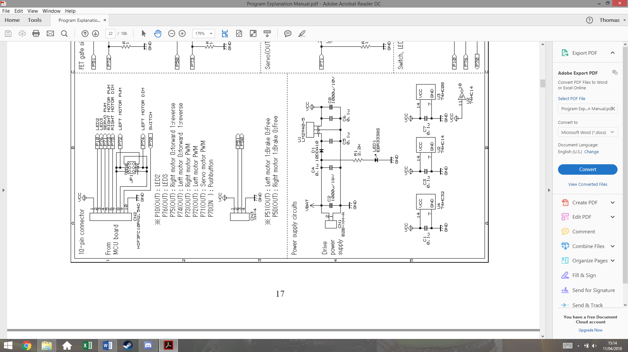This section shows the connections to the MCU board. It’s important to be aware that the Vcc is connected **from** the power board **to** the MCU board.

The ribbon cord from the MCU contains the PWM signals for both motors, and the direction signal for each motor (0 forward, 1 reverse). The only purpose for JP1 is to switch the Left Motor PWM and LEFT Motor DIM signal for other boards. This also contains the pushbutton signal that will be used to run the car.

CN3 is for optional use, and can be used for braking the motors. This is specifically useful for the 90° turns. This would not allow for any dynamic braking as it would completely stop any signal sent to the motors.

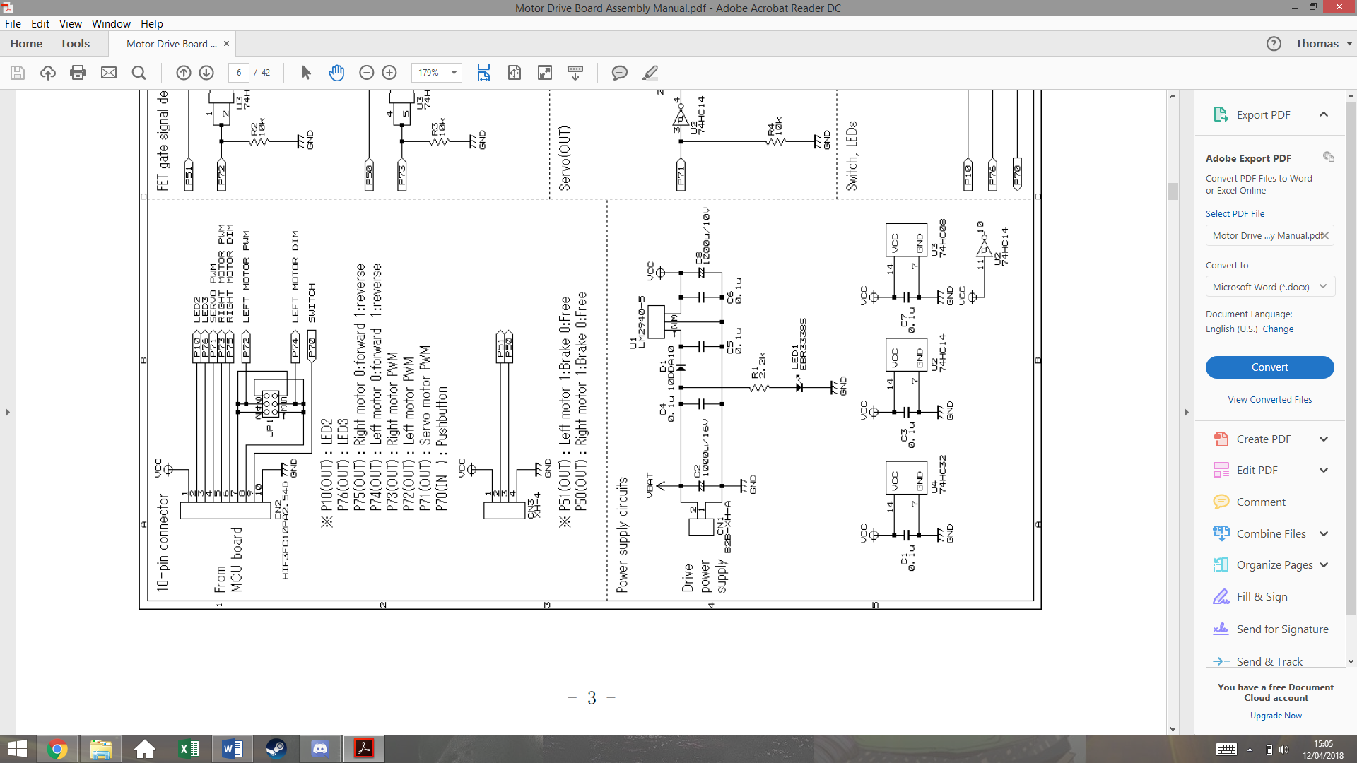

This section shows the power supply of the board. The top circuit regulates the voltage supply Vcc for the MCU board. The LM2940-5 is a 5V regulator that is not included in the initial package. C5 and C6 are also not included so these must be purchased. LED 1 is simply used to indicate that the batteries are connected and that there is power.

The bottom circuit shows the Vcc connected to the logic chips U4, U2 and U3. The capacitors C1, C3 and C7 are decoupling capacitors that remove high frequency components on the supply, often cause by the power supply switching on. This stops the chips being damaged by inrush current.

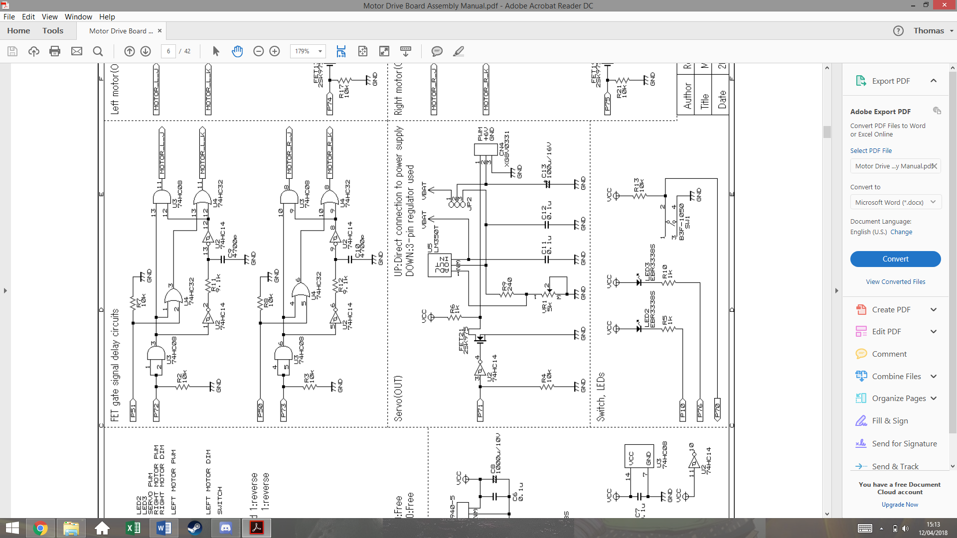This section shows the servo circuit. U5 is another linear regulator not included. This regulator is adjustable via the potentiometer VR1, which can be varied to give a 6V output. Jumper JP2 will have a short between pins 3 and 2, so connect the 6V output of U5 to the servo, instead of the battery voltage on pin 1.

U2 is an inverting Schmitt trigger that both isolated the MCU, stopping current being drawn from the port, and inverts the PWM signal.

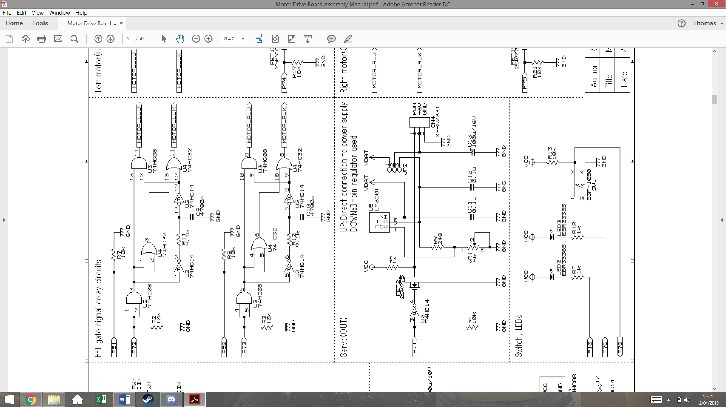

This section shows the logic circuits that control motor direction and speed. Both of these circuits are identical. The first AND gate acts as a buffer that isolates P72/73 on the MCU.

The output Motor_L_J is essentially just P72 but distorted with a delay, as it is the AND function of P72 before and after being filtered by R11 and C9. As it is filtered and then passed through a Schmitt trigger, a delay is created.

The purpose of this delay is to stop a short in the circuit that could be created later. For now, it’s easier to understand with the removal of P51.

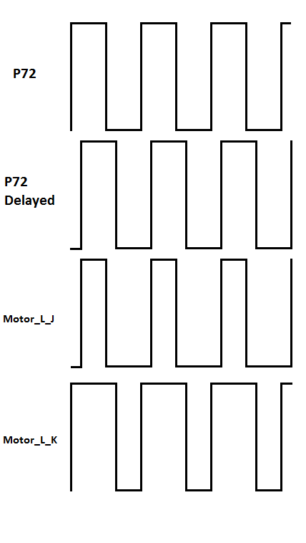This trace shows the output signals of this section of the circuit, without P51. The output Motor_L_K gets inverted by K-FETs in a later circuit. This explains how the short is prevented.

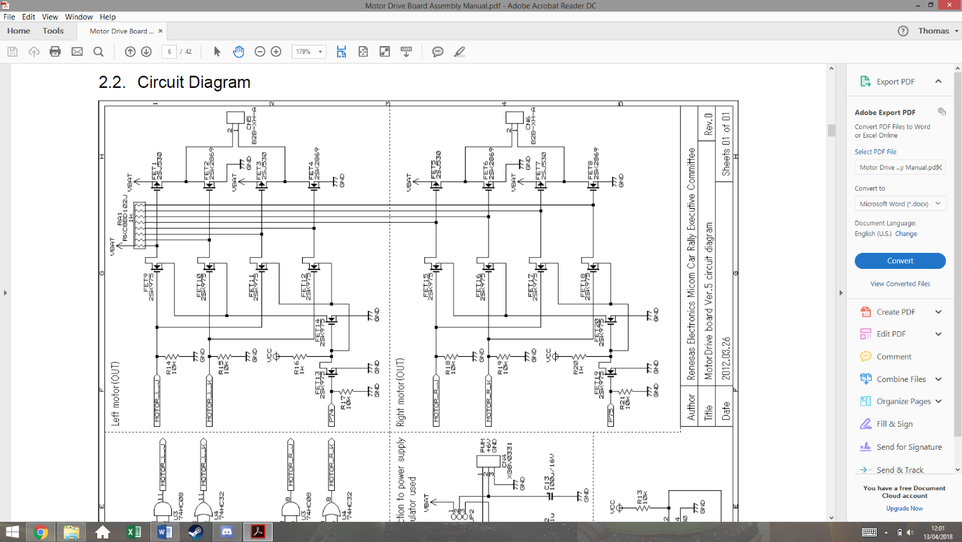

1

2

3

This final section of the power board is the transistor circuit that controls the motors. The bottom and top circuits are the same, but for the two different wheels. The circuit is made of p-channel and n-channel mosfets. It’s important to remember that n-channel allow current flow when the gate is high, whereas p-channel allow current flow when the gate is low.

FET 1, 3, 5 and 7 are p-channel mosfets, the rest are n-channel

The resistor array functions as pull up resistors for the circuit. This means that if all of the FETs on the left and side are in an off state, the gates of the FETs on the right will be high. This will turn the p-channel FETs off and the n-channel FETs on.

If P74 is low, FET13 is off which turns FET14 on. This connects the source of FET9 and 10 to ground. This also connects the source of FET 11 and 12 to Vcc.

This means they are not functioning and keep the signal at their drains high, which hold pin 1 of the motor to ground.

The signal traces for 50% PWM earlier can now be used to analyse this design at points 1, 2, 3 on the schematic. This example has P75 as a value of 0.

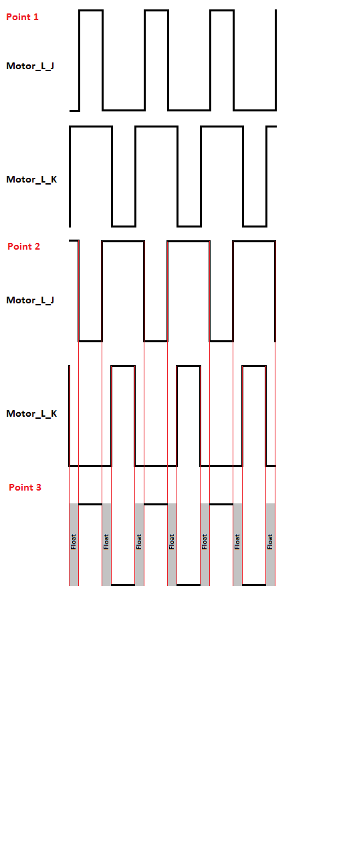

The first trace shows the previously derived waves for input Motor_L_J and Motor_L_K. These signals go to the gates of FETSs 9, 10, 11, 12.

Point 2 shows the signals on the drain pins of FETs 9 and 10, and on the gate pin of FETs 1 and 2. Due to the pull up resistor, when FET 9 or 10 are low, the signal is high, and when the FETs are allowing current flow, the signal goes low, creating this inverted wave.

Point 3 shows how these signals effect this side of the motor input. Due to FET1 being a p-channel FET, when is gate signal is low, it conducts. This produces the wave form at pin 2 of the motor. The delay has created a period when the pin is not connected to Vcc or ground.

This is for safety as if they were ever both connected, a short would be created.

If P74 is on, these same signals will be produced but with FETs 11 and 12 instead, while the outputs of FET 9 and 10 would hold pin 2 of the motor at ground. This effectively applies the same signal but with the pins switched around, reversing the motor.

## Speed Control and Feedback

In order for the car to handle optimally, forms of speed control need to be implemented, so that the car can brake and accelerate dynamically. With one or two feedback methods, a closed loop PID system can be created.

After some brief research, three methods of speed feedback were found, each with their own disadvantages and advantages.

**Optocoupler**- An optocoupler is made from an IR LED and an IR sensor, which will generate a pulse every time light is able to travel between them. This would be implemented by cutting holes in one of the gears and placing the optocoupler across them. The advantage of this is its low cost but would be larger than the alternatives. It would also have to be placed inconveniently above the gearbox, making it hard to get to for fault finding. The decision was made not to implement this method however it would be kept as a backup plan.

**Hall Effect Sensor**- A hall effect sensor is a small IC that will turn on or off depending on the magnetic flux present. This would require magnets to be attached to the real wheels so that the sensor would produce a square wave, with a frequency matching the wheels rotational speed in revolutions per second. The advantage of this is that the sensor would be placed right next to the wheel, making it much easier to access that the optocoupler. The main disadvantage is the need to attach magnets to the rear wheels, slightly increasing the load. This method was decided to be our main form of speed sensing.

**Accelerometer**- While normal used to measure acceleration, and accelerometer could be used with software integration to indirectly measure the speed. The method has the advantage of not having to change the mechanical design in any way, but as it is not a direct speed measurement, it may not be very accurate. This was decided to be a secondary measurement for speed, as well as helping dynamic braking and acceleration by giving acceleration feedback.

### Hall Effect Sensor

A hall effect sensor is and IC that can detect the presence of a magnetic field. They’re often used in motor control to measure rotating magnetic fields. The image below shows and example.

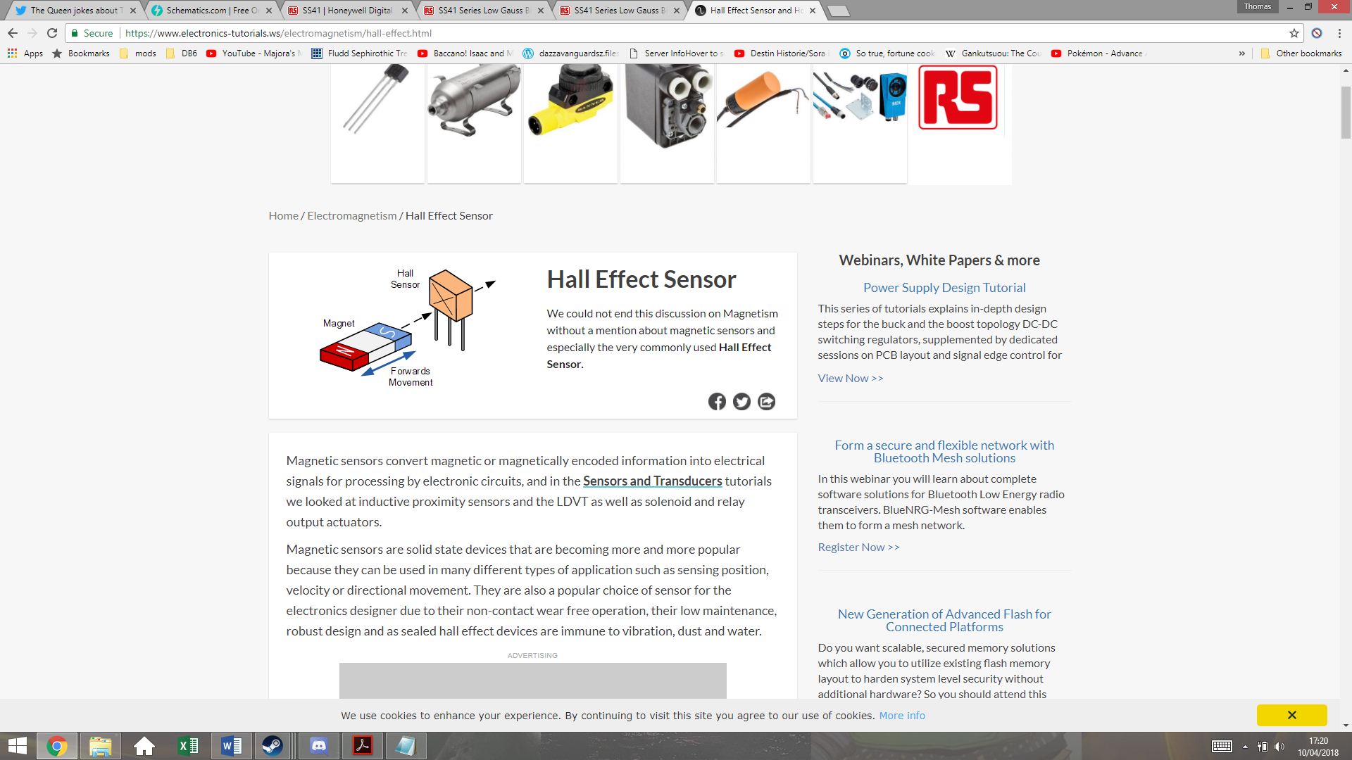

As a southern pole passes in front of the sensor, the output voltage goes high, and as a northern pole passes in front of the sensor, the output will return low. If the magnetic field is removed, it will maintain the same voltage. Meaning that it requires both poles to create an alternating signal.

Figure 3‑1 - Credit www.electronics-tutorials.ws

Both of the rear wheels will have two magnets attached on opposite sides to create a rotating magnetic field. These magnets will be attached with superglue, which should be enough to hold them even when the car is traveling at full speed. The magnets have to be placed exactly opposite each other, or this will create an unbalanced load on the DC motor. The magnets that will be used are Eclipse 5mm Neodymium Magnetic Discs, which are small but powerful. The diagram below shows how they will be positioned.

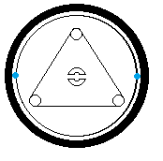The magnets will be placed on the rim of the wheels, next to but not touching the tire. The roll bar connector in the centre of the wheel can be used to make sure they are aligned with each other. These two magnets must be polar opposite so that they switch the sensor on and off with each rotation.

The Hall Effect sensor chosen is the SS41 Honeywell Digital Hall Effect Sensor. It has an input voltage range of 4.5-24V, meaning that it’s suitable to be run of the Vcc of the MCU board. Its maximum current draw when switching with a voltage supply of 5V is 8.7mA, which shouldn’t impact battery life significantly.

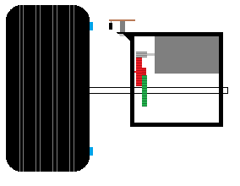

Hall effect sensor

Magnet

This image shows how the sensor must be positioned. The sensor is soldered onto a small piece of Veroboard, which is attached to the gear box using a screw and a spacer. The spacer is to keep it at the same level as the magnet. There is an air gap between the sensor and the magnet, but this should not be large enough to present a problem, given the strength of the magnets used.

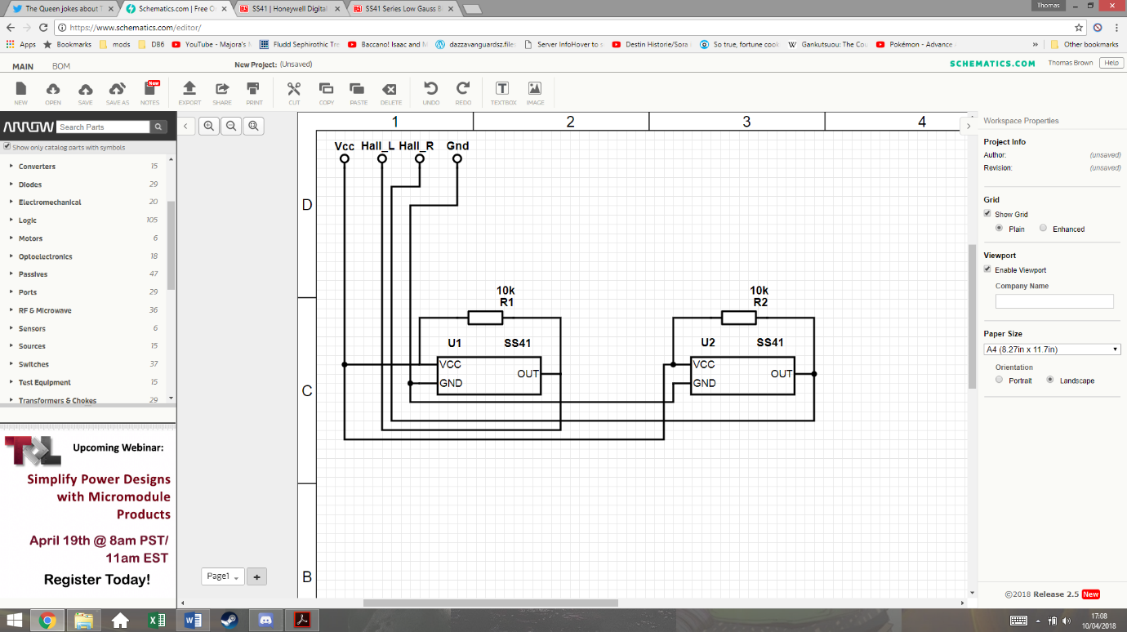This schematic shows how the system will be connected. The two Hall Effect sensors have pull-up resistors that prevent any floating values. They both share the Vcc and ground from the MCU board. The two outputs are then connected to I/O pins on the MCU board.

### Accelerometer

The use of an accelerometer in the car control allows the program to know the forces acting on the car. This can help prevent the car coming out of the track due to inertia and can also help breaking for the corners. For this application, only a two-axis accelerometer is required, as there should be no forces acting on the car perpendicular to the ground.

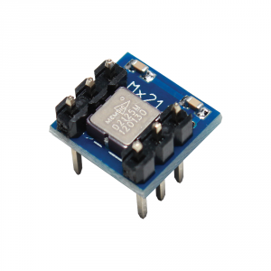The accelerometer chosen is the MESMIC 2125 two axis accelerometer. This can easily be inserted and removed from a standard 6 pin IC socket.

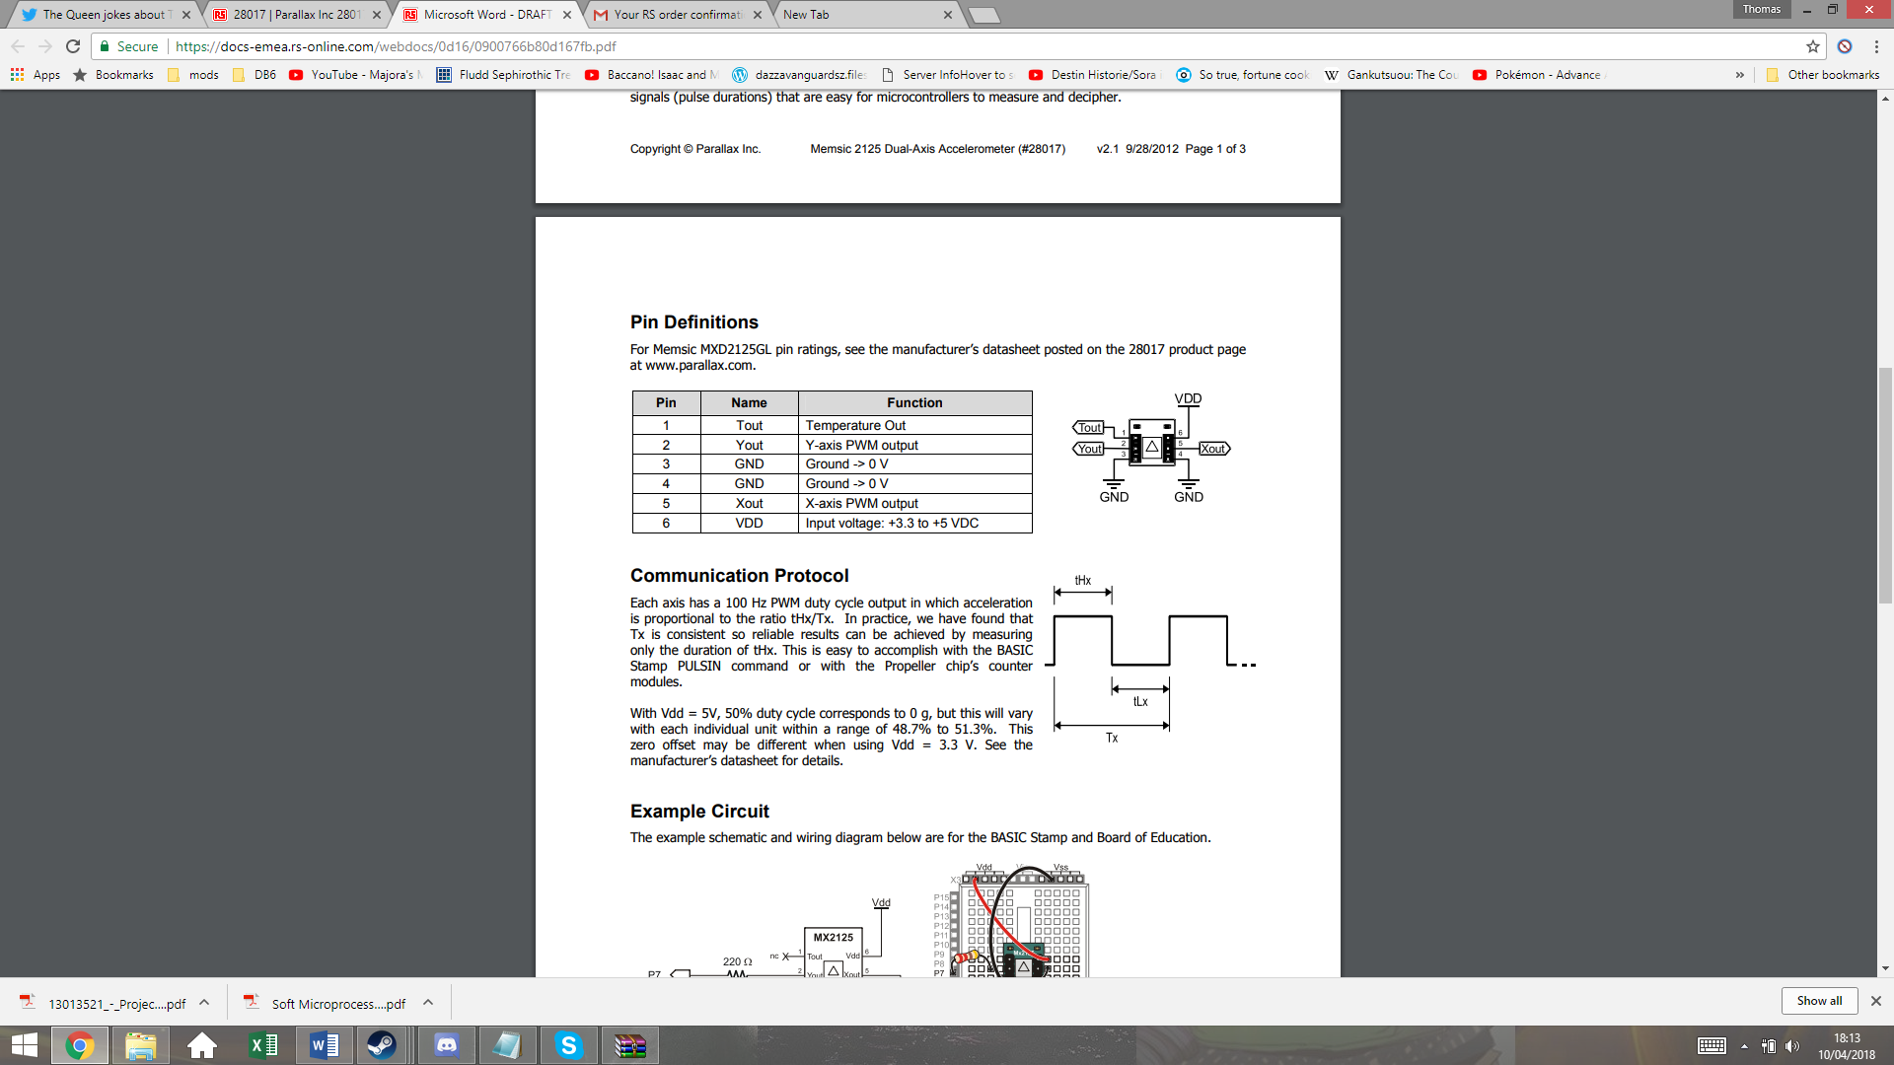

The supply voltage range for this device is 3.3-5Vdc, so this can also be run from the MCU boards Vcc. The output Xout and Yout will be used to give the X and Y coordinates of the vector of acceleration. These output give PWM signals, with duty cycles that vary in proportion to acceleration.

Tout is the temperature output from a thermistor inside the IC, but this will not be used in this system.

The datasheet states a sensitivity of 12.5% duty cycle per g on both axis, with 50% duty cycle representing 0 gg. This gives a range of +/-3 g. Taking g to be 9.81m/s^2, this gives a maximum measurable acceleration of 29.43m/s^2, which the car should not be able to exceed.

## Overall Electronic Design

Below is the overall electronic design, which shows all external connections to the MCU board.

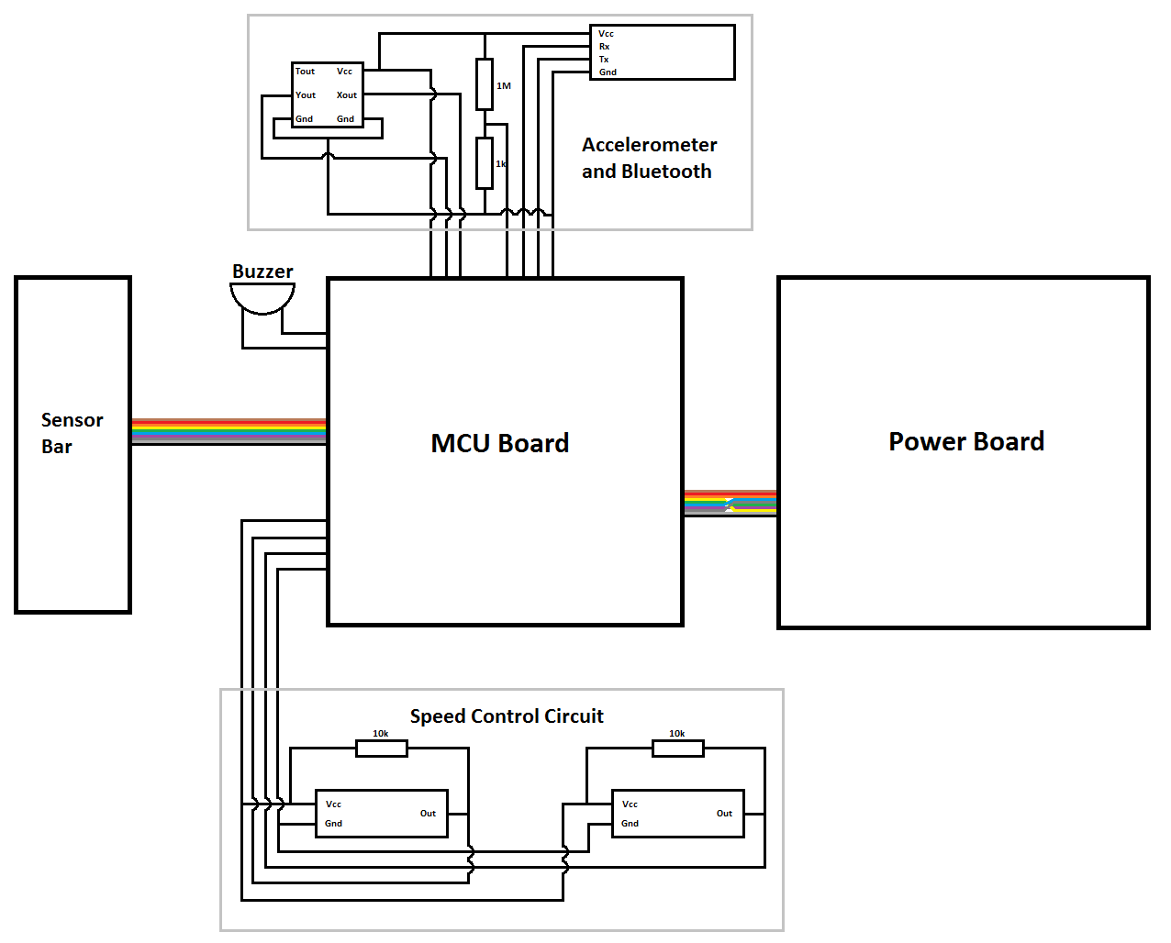

The speed control circuit requires 4 connections, for Vcc, left motor speed, right motor speed, and ground. The buzzer is attached between an MCU GPIO pin and ground, and is separate to the other systems so that it can be physically positioned anywhere. The peripheral board at the top has 7 connections. Vcc and ground for power, Xout and Yout from the accelerometer, Rx and Tx from the Bluetooth, and the scaled down battery voltage reading.

The power and sensor boards are connected via ribbon cord as per the original design.

## Control theory

## Software

The software is built in a modular fashion with each component being entirely independent. The drivers are designed separately and are controlled via a handle that is allocated in memory. This handle identifies a single hardware component and allows the application code to control the physical device without having to know the implementation of the driver at the lower levels. In addition, errors can be isolated to single points of failure, which is ideal for debugging.

Finally, the code was developed on the e2studio IDE instead of HEW, given that it is the most recent IDE provided by Renesas.

### Program structure

In detail, the program can be split into two major designs:

1. Backend – system tasks unrelated to the control of the racing car;
2. Frontend – the application that actually controls the logic of the car.

### Backend

The backend describes the code that executes the background tasks that are not visible to the user application. In this project, these tasks/features are:

|  |  |  |  |
| --- | --- | --- | --- |
|  | Component name | C file/folder name | Description |
| 1 | **Micrium uCOS III - RTOS** | lib/rtos/ | The Real Time Operating System |
| 2 | **Motor driver** | drivers/actuators/motor_driver/ | Controls the two DC motors at the back |
| 3 | **Servo driver** | drivers/actuators/servo/ | Moves the sensor bar sideways by swinging the servo from +- 90º |
| 4 | **Bluetooth driver** | drivers/communications/bluetooth/ | Provides pairing with a computer or smartphone |
| 5 | **Software UART**  **(bit banged UART)** | drivers/communications/protocols/suart | Uses software-defined UART on the Bluetooth module with baud rate 9600. (Hardware UART was not used due to GPIO shortage.) |
| 6 | **Packet manager**  **(layered communication protocol)** | drivers/communications/protocols/packetman/ | Abstracts the extremely simple UART protocol and “packetizes” every single transaction that is made through UART. In essence, it adds a Transport and Application layer on top of the Data link layer (just like TCP/IP). |
| 7 | **Software PWM**  **(bit banged PWM)** | drivers/libs/spwm/ | Software-defined PWM which provides a greater level of accuracy of duty cycles through the use of floating point values rather than a 16-bit value that ranges from 0 to 216-1.  This component is used under the implementation of the motor, servo, piezo buzzer, LEDs and accelerometer. |
| 8 | **LED driver** | drivers/onchip/led.c | Controls the on-board LEDs, as well as the LEDs on the power board. |
| 9 | **Switch driver** | drivers/onchip/switch.h | Reads the push-button switch and returns 1 if the user presses it. |
| 10 | **Accelerometer driver** | drivers/sensors/accel | Measures the momentum of the car in the X and Y axis. |
| 11 | **IR Line tracker driver** | drivers/sensors/ltracker | Reads and returns the measured line in byte format. This pattern is then converted into an equivalent angle later on by the frontend side of the program. |
| 12 | **Piezo buzzer driver / MIDI player** | drivers/sound/piezo.c | Drives the piezo buzzer in order to listen for debugging messages in real-time just as the race is happening. |

Table 3‑1 - Software: the backend structure

Each of these components is then used by the frontend application. If something fails, for instance, the speed of the wheels is not the correct value, then there are two possibilities: either the user application is misusing the driver and generating erroneous calculations for the speed, or the motor driver code is poorly implemented.

This explains why developing an independent C driver for each component is extremely important.

### Frontend

On the other side, we have the application code that “glues” the backend code together and actually uses the developed services in order to control the physical devices for the final purpose – driving the car autonomously.

The logic for that goes into this frontend section. Specifically, we may find the components:

|  |  |  |  |
| --- | --- | --- | --- |
|  | Component name | C file/folder name | Description |
| 1 | **Main thread** | src/app_main.c | RTOS runs this task/thread first. This task then initialises the drivers for the car and waits for the user to press the push-button switch in order to kick-start the car. |
| 2 | **Car controller** | src/app_car_control.c | The previous component triggers this component when the user presses the button.  All of the car control logic goes in this component. |
| 3 | **Car configuration** | src/app_config.h | Stores configuration about the car, for instance, whether the sound is enabled or not, the number of RTOS tasks, the PID coefficients, the integral windup period, etc. |
| 4 | **Track data** | src/app_track_data.h | Stores data regarding the track itself, specifically how many corners exist and the direction of the curve. It also contains a map that converts the measured sensor pattern into an equivalent (approximated) value in angle (degree) format. |
| 5 | **Template generator** | src/app_template_generator.c | Allows the car to read the sensor data while it’s running and sending this same data to the computer in a burst in order to allow “playback” of the measured track at a later time. This feature is used in the ‘Smart mode’ described on section **4.3.2.1.2 – Levels of intelligence**. |
| 6 | **Shell command line** | lib/shell | Provides an interface for the user to type commands in order to control the car. (This connection is done via Serial COM port through the Bluetooth module HC06.) |

Table 3‑2 - Software: the frontend structure

# Implementation

## Mechanical

The mechanical build started by using the provided plastic board to cut out and shape the bottom level board (point 1). This was cut out using a hacksaw and then a file and sandpaper were used to shape it and smooth down any rough edges.

This process was then repeated for the servo bridge and servo reinforcing plates (point 2). The servo reinforcing plates where attached to the bridge with screws and nuts so that they could be filed down together, however they would have to be removed later to attach the servo. The bridge was then attached to the bottom level board with the four pillars.

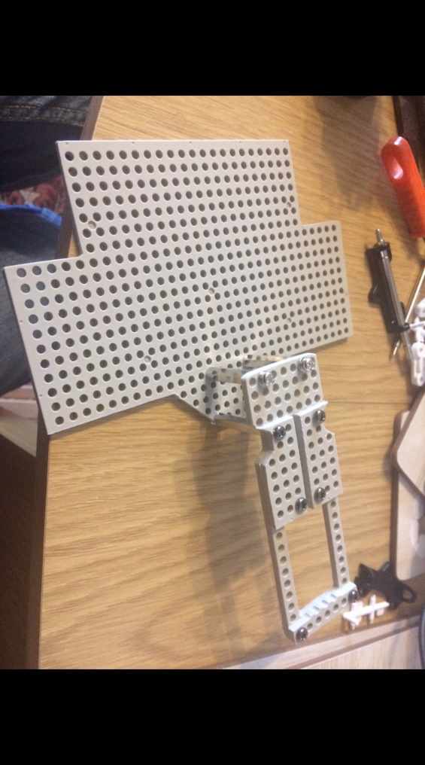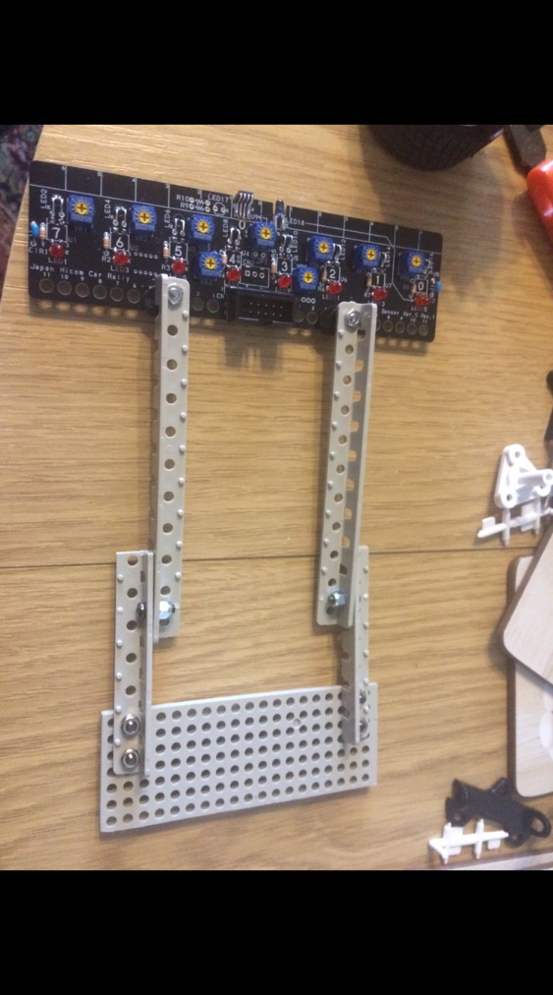

1

2

3

4

The axel is then cut out and shaped (point 3) but this is relatively easy as it’s just a rectangle. The arms are then assembled. The top part of the arms are already the correct length and shape, but the lower arms must be cut and smoothed.

The nylocs can be seen (point 4) one hole in to the lower part of the arm. This extra hole could be used to extend the length of the arms later on. The theory was that while longer arms may put more load on the servo, it would allow the car to detect changes in the line earlier.

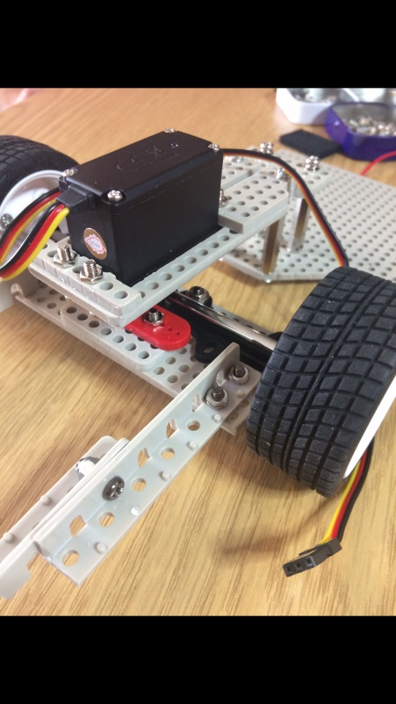

The servo is then attached to the front axle via the red servo horn, and then mounted on the servo bridge using the reinforcing plates. A spacer is placed between the servo horn and the axle plate so that the wheels are the correct distance down from the servo.

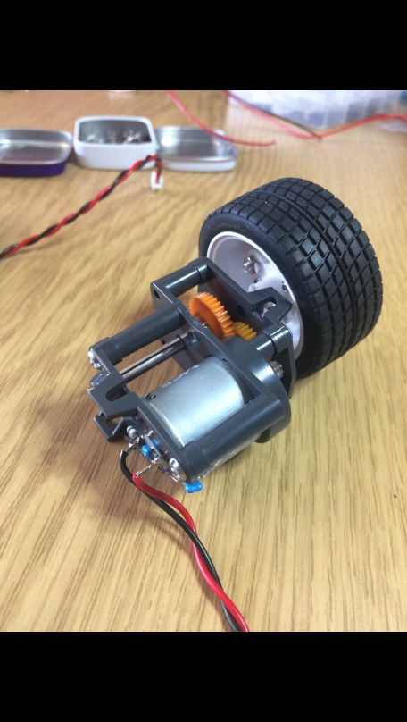

The gearboxes are then assembled ready to be mounted on the back. The motor is inserted into the housing before the capacitors and wires are soldered on, so that the contacts can slot through the back of the housing. The purpose of these capacitors are to filter noise and high frequency voltages from the PWM signals.

Once the wheel has been attached to the shaft and inserted into the housing, any extra shaft is cut away so that the gearboxes can be placed closely together. The shaft is held in place by a hexagonal gear joint and set screw. The gears are then positioned to complete the gearbox.

## Electrical

### Provided Circuits

The servo board was a simple build, however did require some accuracy in aligning the IR LEDs so that they all gave out an equal amount of light. After the build the potentiometers was adjusted to each give an equal voltage to the sensors, however this would be adjusted later to give the best sensitivity.

The power board was a much larger build, and to reduce the amount of time that may have been spent on fault finding, a great deal of care was put into the soldering of each component. The logic gate chips were soldered on a lower heat so as to be sure that they wouldn’t break.

The extra regulator components were added after testing the power board with a 5V supply.

### Hall Effect circuits

The image below shows one of the Hall Effect sensor board.

This was created by using a hacksaw to cut two small rectangles out of a piece of Veroboard, and then drilling the appropriate holes. The components were then soldered according to the schematic, making sure that there is no electrical path to the screws.

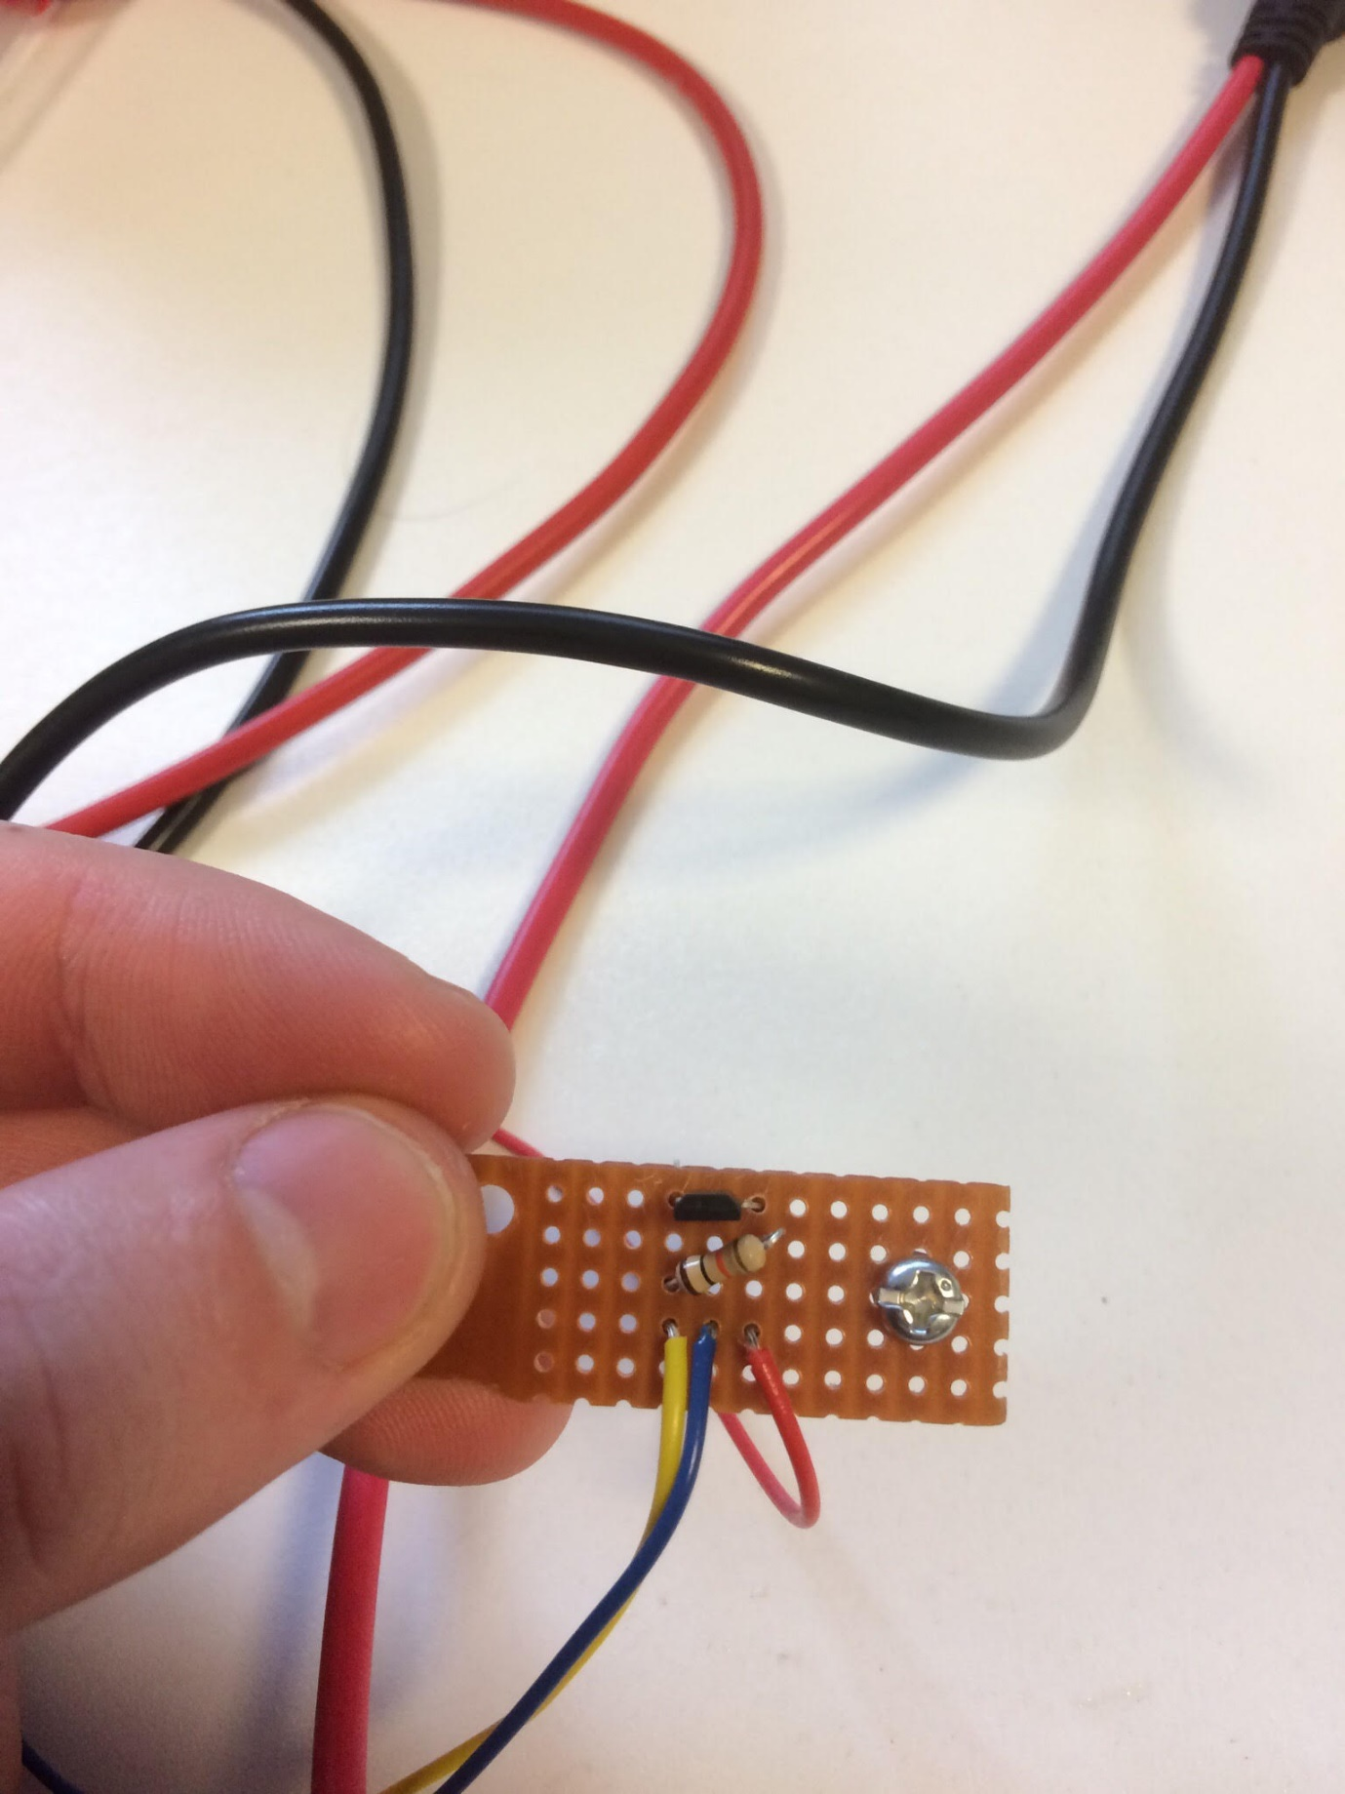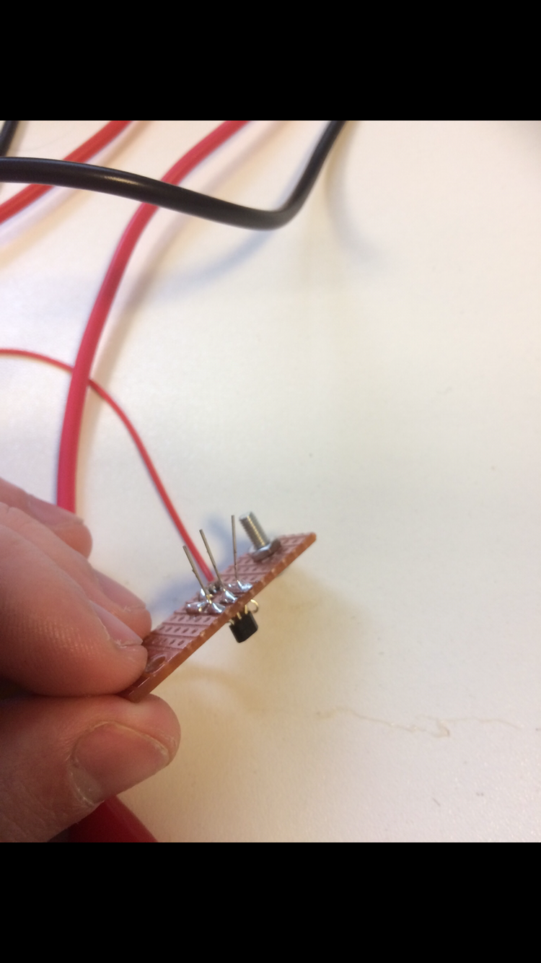

The legs of the Hall Effect sensors are not cut off just yet, as it makes testing easier if the legs are big enough to have crocodile clips attached.

### Peripheral Board

The peripheral board was an easy build. IC sockets were cut to the right sizes so that the accelerometer and Bluetooth systems could be removed is needed and didn’t have to be soldered directly. This is important because the accelerometer relies of temperature to function and exposing it to high temperatures could make it in accurate. Any extra copper on the Veroboard has been scratched away so as to reduce the risk of there ever being a short circuit.

Holes were drilled in the Veroboard so that it could be mounted behind the servo, as per the mechanical design, with spacers so that the bottom of the board does not touch the structure. The wires from the board are trimmed so that they are only as long as they need be, as they could otherwise get caught on something.

## Software

This section covers the implementation of the software from the two perspectives Backend – Frontend. It explains how the main components function internally and how they provide their own service/output data to the application code.

### Backend

#### RTOS

For this project, a Real Time Operating System (RTOS) was necessary to deal with the many components accurately and safely. This provides fine control on each task, allowing us to execute a certain operation periodically with guaranteed certainty that it will deliver. If an issue occurs during the execution of a task, RTOS makes sure the entire system either halts or pauses the faulty task in order to prevent the rest of the system from entering a “buggy” state.

The RTOS being used is the open source uCOS III from Micrium, which runs on a variety of platforms, from ARM and RISC-V to Renesas’ set of architectures, such as the RX62G/RX62T.

#### Peripheral drivers

As was already described on the previous section, the drivers are built entirely separately. Each driver is implemented in a way that allows the application to run only the necessary functions, while keeping the private inner functions hidden away from the application. A physical device is abstracted into what is called a handle, or a pointer, which is dynamically allocated on the heap with the use of the malloc function.

##### Motor driver

The most important driver is what makes the car move. This module uses software defined PWM to output the signal and drive the motor. It also features differential calculations, which is achieved through the PID output. The diagram below shows the inner functionality of the code for the motor.

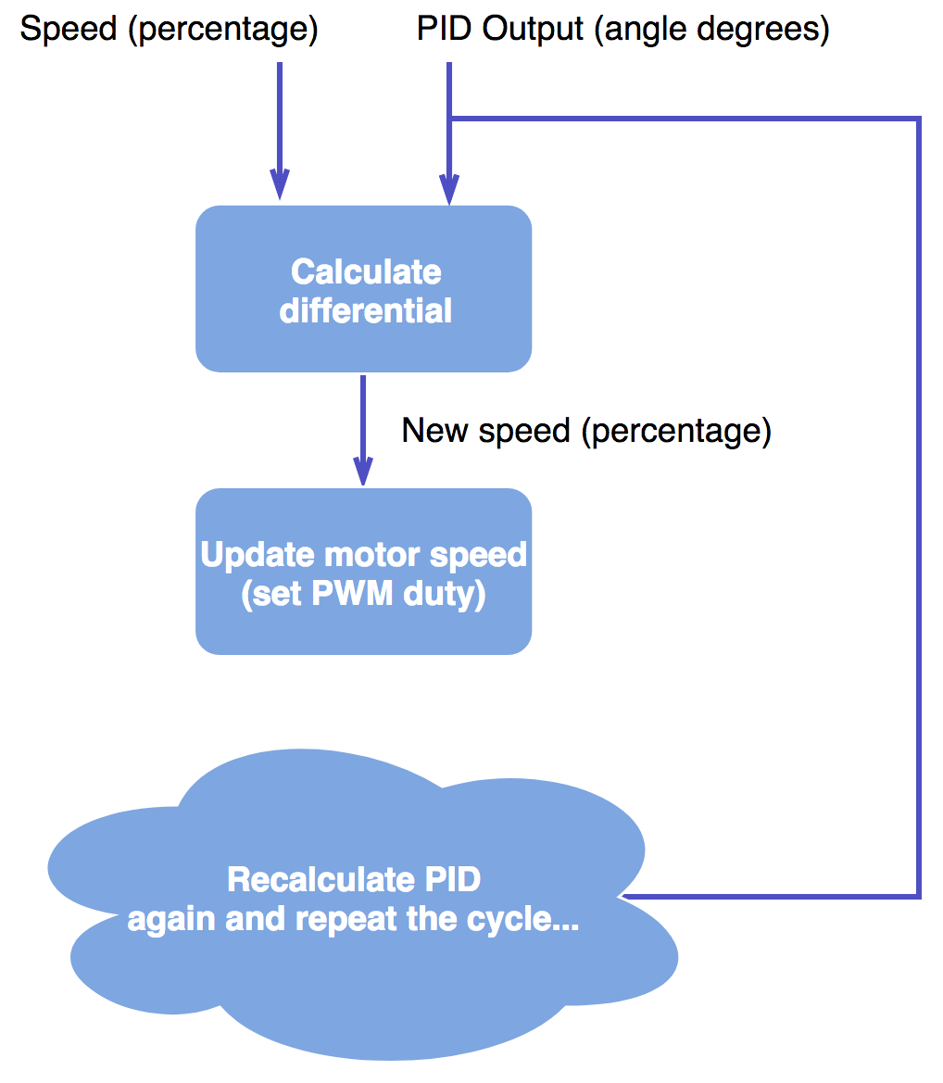

The supported API (Application Programming Interface) for this driver may be found below:

|  |
| --- |
| **typedef** **struct** {  ***spwm_t*** * *dev_handle*;  **float** *speed*; /* Expressed in % from 0 to 100. Value can be negative (for reverse rotation) */  **float** *speed_old*;  **float** *speed_safe_old*;  **float** *max_speed*;  **float** *deceleration*;  **float** *rpm_measured*;  ***uint32_t*** *rpm_timestamp*;  ***uint32_t*** *rpm_timestamp_old*;  bool *rpm_timestamp_triggered*;  bool *is_braking*;  bool *is_safemode*;  bool *is_stopped*;  **enum** **MOTOR_CHANNEL** *side*;  } ***motor_t***;  ***motor_t*** * motor_init(**enum** **MOTOR_CHANNEL** channel);  ***motor_t*** * motor_init_safe(**enum** **MOTOR_CHANNEL** channel, bool enable_safemode);  **enum** **MOTOR_RETCODE** motor_reset(***motor_t*** * handle);  **enum** **MOTOR_RETCODE** motor_stop(***motor_t*** * handle);  **enum** **MOTOR_RETCODE** motor_stop2(***motor_t*** * left_motor, ***motor_t*** * right_motor);  **enum** **MOTOR_RETCODE** motor_resume(***motor_t*** * handle);  **enum** **MOTOR_RETCODE** motor_ctrl(***motor_t*** * handle, **float** speed_percentage);  **enum** **MOTOR_RETCODE** motor_ctrl2(***motor_t*** * left_motor, ***motor_t*** * right_motor, **float** speed_percentage);  **enum** **MOTOR_RETCODE** motor_ctrl_with_differential(***motor_t*** * handle, **float** speed_percentage, **float** pid_output);  **enum** **MOTOR_RETCODE** motor_ctrl_with_differential2(***motor_t*** * left_motor, ***motor_t*** * right_motor, **float** speed_percentage, **float** pid_output);  **enum** **MOTOR_RETCODE** motor_refresh(***motor_t*** * handle);  **enum** **MOTOR_RETCODE** motor_refresh_with_differential(***motor_t*** * handle, **float** pid_output);  **enum** **MOTOR_RETCODE** motor_refresh_with_differential2(***motor_t*** * left_motor, ***motor_t*** * right_motor, **float** pid_output);  **enum** **MOTOR_RETCODE** motor_set_safe_mode(***motor_t*** * handle, bool enable, bool update_speed);  **enum** **MOTOR_RETCODE** motor_set_speed(***motor_t*** * handle, **float** speed_percentage);  **enum** **MOTOR_RETCODE** motor_set_speed2(***motor_t*** * left_motor, ***motor_t*** * right_motor, **float** speed_percentage);  **enum** **MOTOR_RETCODE** motor_set_braking(***motor_t*** * handle, bool is_braking);  **enum** **MOTOR_RETCODE** motor_set_braking2(***motor_t*** * left_motor, ***motor_t*** * right_motor, bool is_braking);  **enum** **MOTOR_RETCODE** motor_set_max_speed(***motor_t*** * handle, **float** new_max_speed); |

These functions are used by the application code. As can be seen, the driver allows the application to:

1. Initialise the motor in two different ways (normal and safe mode, which is just normal mode with the speed capped to a safe level);
2. Allows resetting the module variables (see the motor_t struct for reference)
3. Supports stop and resume functions;
4. Control of the motor with new speed (ctrl) with or without differential enabled;
5. Control of the motor with just differential (using the PID output) but with the same baseline speed;
6. Disable of enable safe mode while the car is running;
7. Change the speed variable without refreshing the actual speed of the motor (Useful if there are still calculations pending and we might not want to commit the calculated speed just yet.);
8. Brake the motors to a fixed global speed already defined in the app_config.h header;
9. Change the maximum allowed speed (both in normal and safe mode).

Finally, in addition to this, it is possible to reverse the motors by providing a negative percentage speed.

##### Servo driver

The servo is implemented with lower complexity, since it is a much simpler device compared to the motors (from the programming perspective).

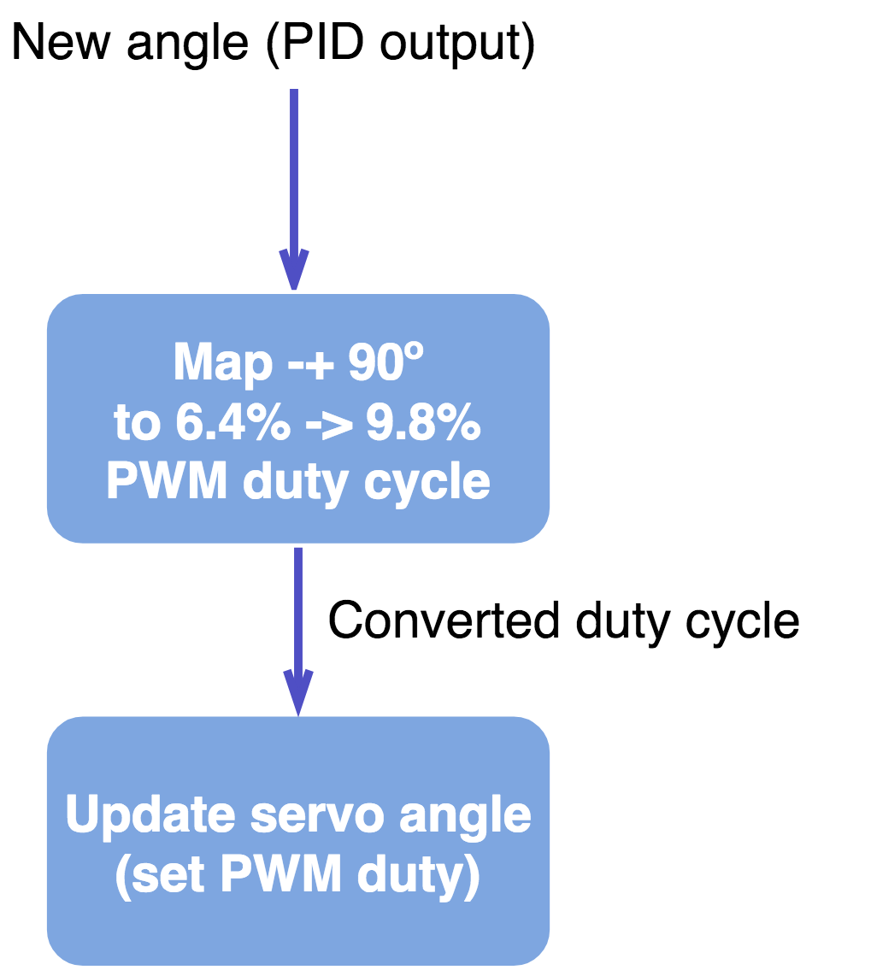

This is the only process being executed by the servo driver. It receives an angle that ranges from -90 degrees to +90 degrees to a duty cycle supported by the servo, which is from 6.4% to 9.8% with a PWM frequency of 50.08 Hz.

Its API:

|  |
| --- |
| **typedef** **struct** {  ***spwm_t*** * *dev_handle*;  ***int8_t*** *angle*;  ***int8_t*** *angle_old*;  bool *is_locked*;  bool *is_sweeping*;  } ***servo_t***;  ***servo_t*** * servo_init(**void**);  **enum** **SERVO_RETCODE** servo_reset(***servo_t*** * handle);  **enum** **SERVO_RETCODE** servo_ctrl(***servo_t*** * handle, ***int8_t*** angle);  **enum** **SERVO_RETCODE** servo_accum_ctrl(***servo_t*** * handle, ***int8_t*** sum_angle);  **enum** **SERVO_RETCODE** servo_center(***servo_t*** * handle);  **enum** **SERVO_RETCODE** servo_lock(***servo_t*** * handle);  **enum** **SERVO_RETCODE** servo_unlock(***servo_t*** * handle);  **enum** **SERVO_RETCODE** servo_sweep(***servo_t*** * handle, ***int8_t*** min_angle, ***int8_t*** max_angle, ***uint32_t*** delay, ***int8_t*** increment, bool from_cur_angle); |

It features:

1. Initialisation and reset of the servo variables;
2. Control of the servo angle;
3. Control of the servo angle by the process of angle accumulation (example: control the angle by setting it 1 degree at a time. It will move 1 degree and this will be accumulated with the angle variable);
4. Centre the servo on angle 0 degrees;
5. Lock the servo in its position - constantly outputs the PWM signal;
6. Unlock the servo - the PWM signal is not persistent. When the angle is changed, it is changed once and the PWM signal is disabled once the servo is in the desired place;
7. Sweep the servo – moves the servo from -90 degrees to +90 degrees. Useful for checking if both the servo and the code is working.

##### IR Sensor driver

The line tracker driver is possibly the simplest piece of code in this project. It reads the PORT4 of the microcontroller, inverts its bits and ‘ANDs’ the result with a mask value.

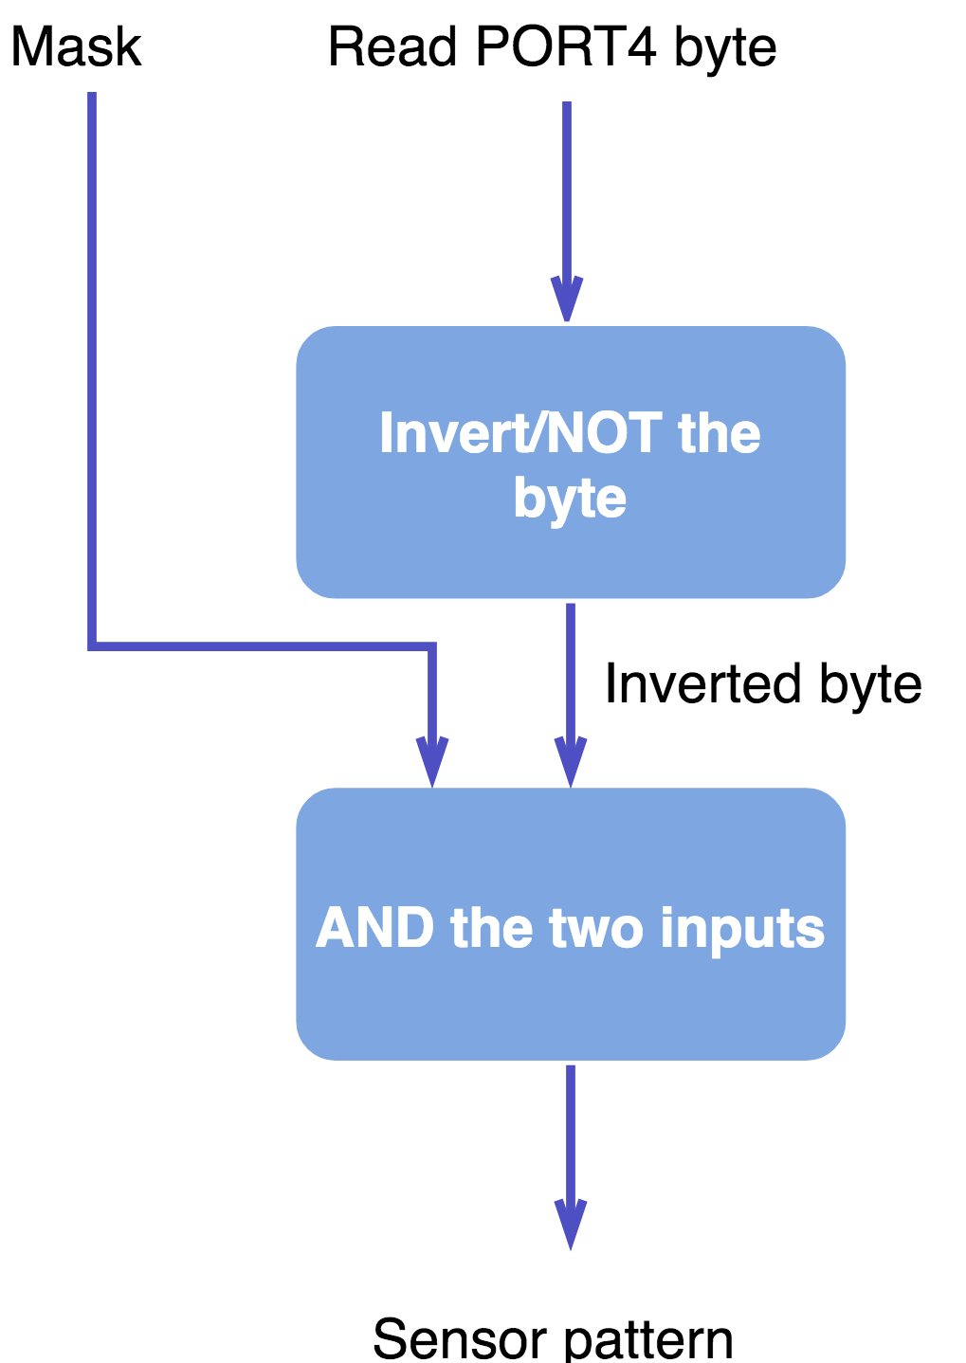

The output sensor pattern is extremely important, however. It is the only real indication the car has to determine where the line of the track is located at. There are no other visual mechanisms to detect the line, other than predictive calculations and machine learning.

There is one problem, however. We needed to convert a pattern in byte format, which has no meaning and is unusable (in its raw format) into a compatible angle to be used by the servo and motor drivers. The process by which this problem is solved is through a lookup table combined with a PID controller.

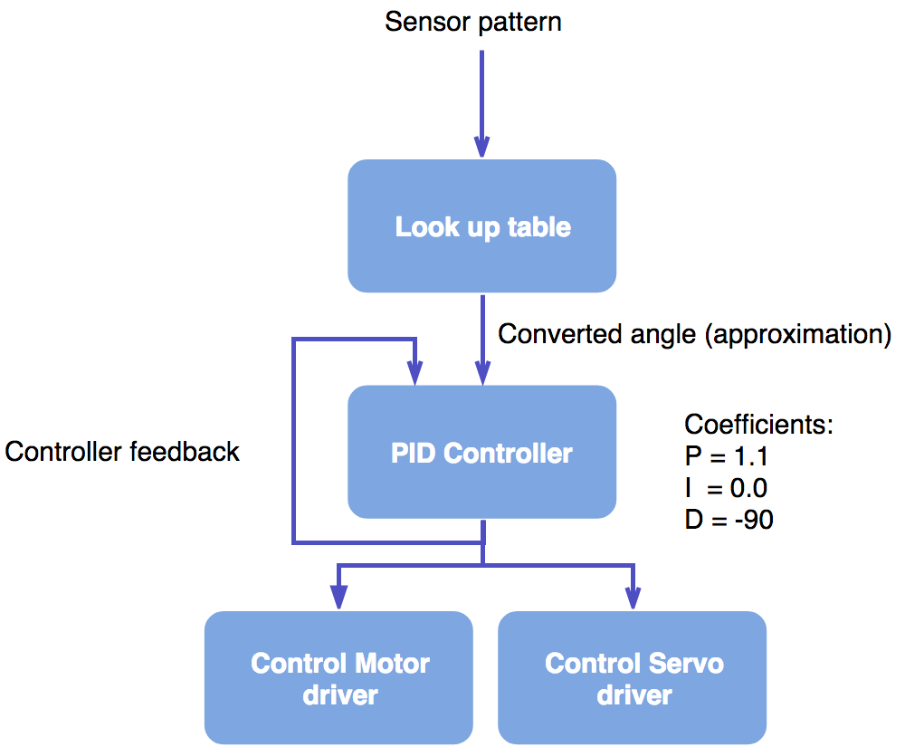

Figure 4‑1 - Implementation of the controller for the car

This is in fact how the core control of the car is implemented. All of the components implemented are used together in this way in the application frontend.

##### Speed sensor driver

One last component that is missing from the Figure 4-1 is the speed sensor driver. The code for this is implemented inside the motor driver, and it is implemented with the help of RTOS’ timing services.

Algorithm:

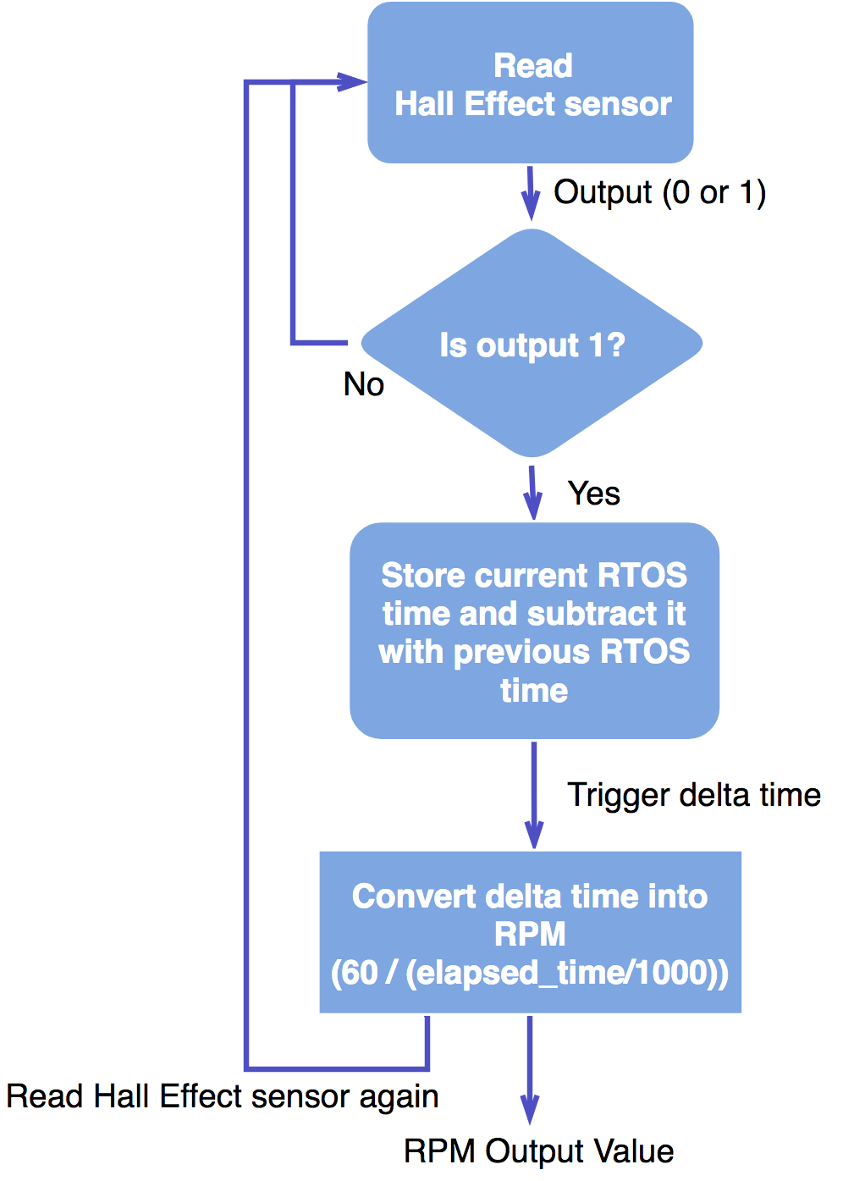

The RPM output value then contributes to the differential algorithm. If the RPM is too high, the differential effect is much greater, since the car would be at a state with large momentum. In this situation, if the car encounters a large angle (i.e. a large difference in the PID output), slowing down the car further to contain the momentum would be absolutely necessary as to prevent the car from getting out of the track.

#### Communication protocol

### Frontend

#### User application – car controller

##### Algorithm

##### Levels of intelligence

###### Basic

###### Advanced

###### Smart

#### User interactivity – command shell and Android App

### Extra features

#### MIDI Player

#### Wireless firmware deployment (bootloader)

#### Backward and forward compatibility

# Testing

## Mechanical

Mechanically there was little to test, however the endurance of the car had to be ascertained so that the car could handle to trip to Germany. The car was set to run at full speed for five minutes to make sure that the gearboxes functioned well at highest stress. This revealed a critical problem. As the gears spin at high speeds from a prolonged time, the nib of the gear wore away the hole it sits in the housing (point A), causing the gears to fail.

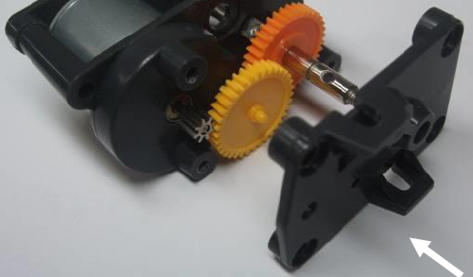

This was fixed by filing down that part of the housing so that the nib pokes all the way through, stopping it from wearing away the plastic.

Other than this there were no mechanicals problems. The design was sturdy and could take minor knocks without being damaged. The Velcro functioned very well in allowing the batteries to be removed quickly for charging.

## Electrical

### Sensor board

<NOTE: KAYIN, WRITE YOUR CONTENT HERE>

### Power board

The power board was tested in a few ways. The first test involved connecting the power supply and checking the output voltages from the regulators. The 5V regulator for the MCU board maintained a constant voltage of ~4.9V, which is perfectly accurate for this purpose.

The adjustable regulator was tested with a multimeter and adjusted until the output was 6V. This was checked regularly throughout the project so as to be sure that the potentiometer hadn’t been accidentally turned.

Lastly the output signals are checked to see that they operate as intended. The signals do indeed line up with those mentioned in the design.

### Hall Effect Sensors

The first test that was conducted on the Hall Effect circuits, was to move a magnet at a distance of ~2.5cm to see that the sensors were working correctly. This was a success, and the signal switched between 5V and 0V when exposed to magnetic south and north respectively.

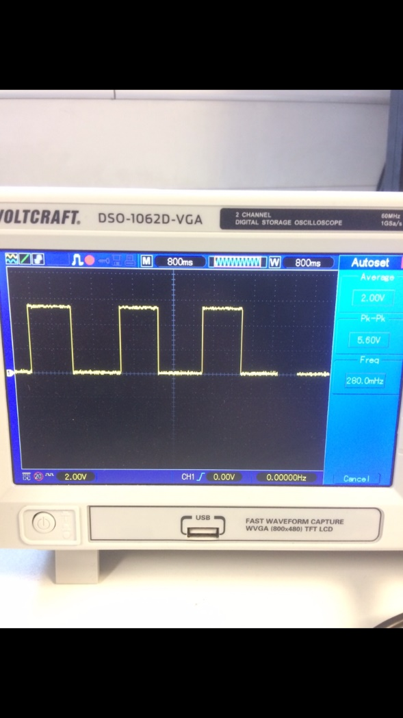The next test involved monitoring the sensor signal as the wheel is rotated by the rear motors. For this test the motors where disconnected from the power board and connected to a variable power supply with a PWM output. The actual speed of the motor was read with a laser tachometer.

The results of these tests can be seen below:

|  |  |  |  |  |
| --- | --- | --- | --- | --- |
| Motor PWM (%) | Motor Speed (Rpm) | Hall Effect Frequency (Hz) | Hall Effect Speed (Rpm) | Error (%) |
| 20 | 1906 | 31.4 | 1881 | 2 |
| 30 | 2894 | 47.5 | 2851 | 1 |
| 40 | 3832 | 67.2 | 4032 | 5 |
| 50 | 4813 | 81.6 | 4896 | 2 |
| 60 | 5770 | 98.9 | 5933 | 3 |
| 70 | 6721 | 106.4 | 6384 | 5 |
| 80 | 7692 | 125.4 | 7526 | 2 |
| 90 | 8637 | 145.4 | 8726 | 1 |
| 100 | 9602 | 160.8 | 9650 | 0.5 |

The Hall Effect error doesn’t seem to exceed 5% error, making it accurate enough for this system but could be made better, possibly by adding a second pair of magnets to each wheel.

## Software

# Performance

# Problems and solutions

<NOTE: KAYIN, WRITE YOUR CONTENT HERE>

# Next year proposals

# Discussions

# Conclusion

# References

Appendices

Appendix A:

Appendix B:

Appendix C: